Become a Member
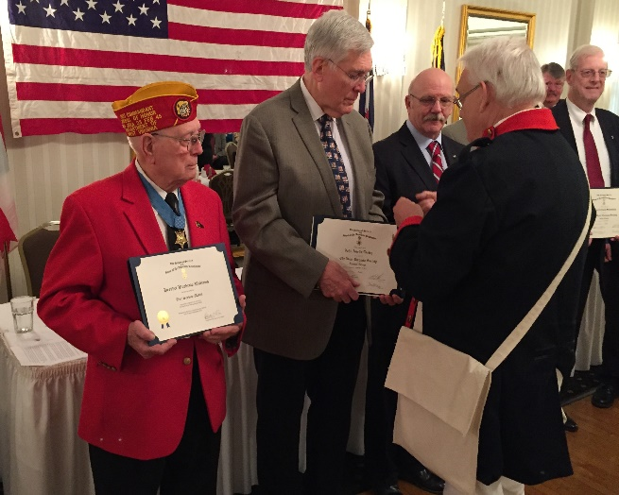

Membership is open to any male, regardless of age, who can prove lineal descent from a man or woman who contributed to obtaining our country’s freedom from Great Britain. It does not have to have been military service. Civilian service, such as being a public official, serving on a jury, paying a supply tax or providing support to the army is included.
You will need to document your lineage from your revolutionary ancestor. This can be an involved process and we are available to help. You can check the SAR website (www.SAR.org) or your local chapter contact listed below.
____________________________________
____________________________________
___________________________________

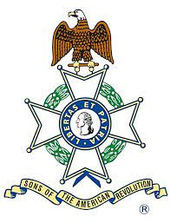

The Sons of the American Revolution is a non-political, patriotic, educational 501c3 organization of male descendants of the patriots who fought in, or otherwise supported the War for Independence that led to the creation of the United States of America.
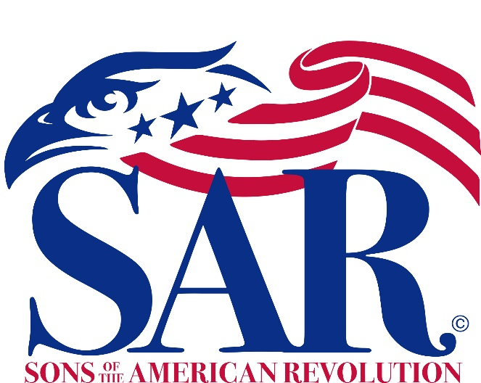

Honoring the Past
Serving the Present
Preparing for the Future

Just a few of our many activities are highlighted here. Please contact us to join our ongoing celebration of American freedom.

Honoring the Past
- We celebrate the 250th Anniversary of the American Revolution

- We mark the graves of our patriot ancestors

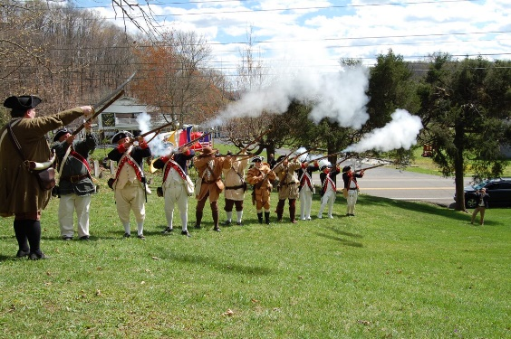

- We commemorate historic events and help maintain historic sites

- We participate in Wreaths Across America to honor our past veterans

Serving the Present
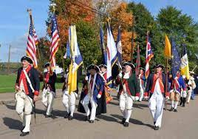
- We provide color guards for parades and other civic events

- We honor people who proudly fly the American flag

- We support services to our military veterans and honor our first responders.

- We honor teachers of American History

- We maintain a genealogy research library and and are preparing a museum of the American Revolution

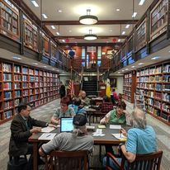
Preparing for the Future

- We provide educational outreach about American history and ideals
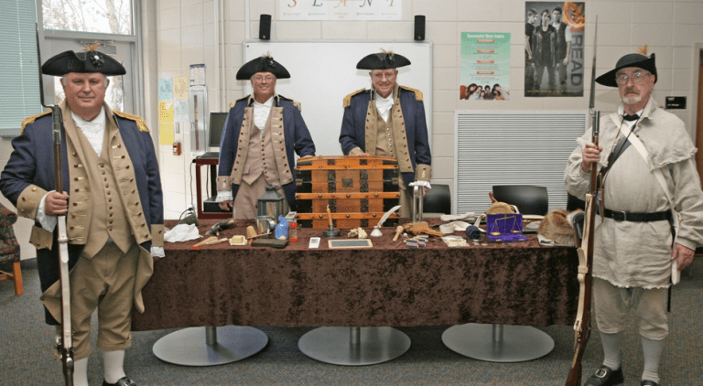
- We promote good citizenship and recognize outstanding high school students

- We sponsor writing, speaking, brochure, and poster contests related to the American Revolution for students of all ages

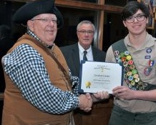

- We honor Eagle Scouts and members of ROTC and JROTC

