Sidney C. Hughes
Click or tap here to enter text.
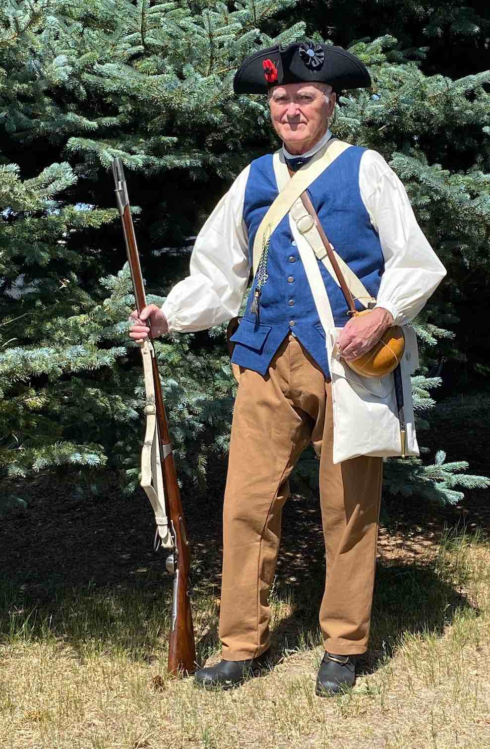
Contact Information:
Address: 2031 Deerpath Trail, Franktown, CO 80116

E-mail: sidhughes@mac.com

Home Phone: 303-660-1734

Cell Phone: 303-917-7380

SAR Chapter: Pikes Peak

State Society: Colorado

Experience:

I have participated in Patriot Chest presentations since 2018.

Lecture Topics/Costumes:

Events leading up to the Revolution, Life in Colonial America, Intro to Colonial Militia. I have typical colonial militia uniform/costume.

Specialty Lecture Topics:

Introduction to Military Records research. South Carolina Militia

Lecturing Credentials:

I have developed and presented historical reports to my Chapter and am currently scheduled to present an introductory class on researching military records to my wife’s DAR Chapter. I was an ROTC instructor for 3 years while active duty U.S. Army.

Presentation Requirements:

Large table to display Patriot Chest items. Research presentation requires computer/AV support. Can be done remotely using Zoom

Audio-Visual Equipment:

Computer/AV projector and screen or HDMI TV for research presentation. Can be done using Zoom to remote groups.

Length of Program:

Patriot chest, approximately 45 to 60 minutes. Research presentation 60 to 90 minutes, additional time can be allowed for questions. Can modify to fit allotted time slots.

Appropriate Age Groups:

Middle School students. Have presented to various ages at a summer camp program. Can present to groups of all ages.

Handouts:

Patriot Chest: none. Research presentation: on request

Travel Range:

+/- 60 miles depending on length of overall program and group.

Fees:

None

Resources:

Militia uniform (several combinations) Firelock and accessories on loan from fellow Compatriot. Chapter Patriot Chest

