Brooks Lyles
Contact Information:
Address: 557 Lincoln Quarters Lane, Tega Cay, SC 29708
E-mail: brooks.lyles@gmail.com
Home Telephone: (913) 680-1602 Cell Phone: (913) 306-4261
SAR Chapter:
State Society: International

Experience: Brooks is a retired Army Officer with a BA in History from James Madison University and a MA in Administration from Central Michigan University. Among his assignments over his 22+ year military career was as an instructor in the Tactics Department at the US Army Command and General Staff College. He has held positions within the SAR at all levels, including Vice President General of the International District, State Society President, Chapter President, National Education Committee Chairman, National History Committee and Partners in Patriotism Vice Chairmen and 3rd Adjutant of the SAR National Color Guard.

Lecture Topics/Costumes: Brooks has several presentations available on Colonial America and the Revolutionary War. His most recent presentations are entitled ‘The Road to Yorktown” and “Citizen Soldiers: Militias and Militiamen” which is presented in the dress of a local Militia or ‘Minuteman’. He has presentations on the Revolutionary War Battles of Kings Mountain, Cowpens, Guilford Court House, The Road to Lexington and Concord, and Princeton as well as on the Battle of Fort Necessity (or how George Washington started the French and Indian War). Additional presentations include ‘The Ride of Sybil Ludington’ and ‘Abram Penn, A Life of Service’ about his Revolutionary War ancestor. He can appear as a Militia man, a Continental Officer, or as a Continental Rifleman. His living history program includes discussions of colonial era artifacts with a “traveling trunk” which contains soldiers’ military equipment and accessories. He can discuss the uniforms of the day and, with prior approval from the group, weapons to include the Pennsylvania Long Rifle seen in the photo, a Hessian Jaeger Rifle, a Brown Bess Musket and a flintlock Horse Pistol.

Specialty Lecture Topics: Soldiering during the American Revolution. Special Topics can be requested with advanced notice.

Lecturing Credentials: Routinely presented programs for lineage societies (Sons of the American Revolution and Daughters of the American Revolution) and has done a Constitution Day presentation for his granddaughter’s elementary school. Trained instructor at the US Army’s Command and General Staff College. Youth Protection Training Certified by the Boy Scouts of America.

Presentation Requirements: need a 6-8 ft. table for display of materials and a room which allow participants to see and participate in presentations with the Travelling Trunk, no restriction on group size.

Audio-Visual Equipment: Projector and screen suitable for a laptop connection and power source for the historical presentations. Microphone/speaker system should be provided if desired.

Length of Program: Min: 30 mins with Q&A. Max: 1 ½ Hr.

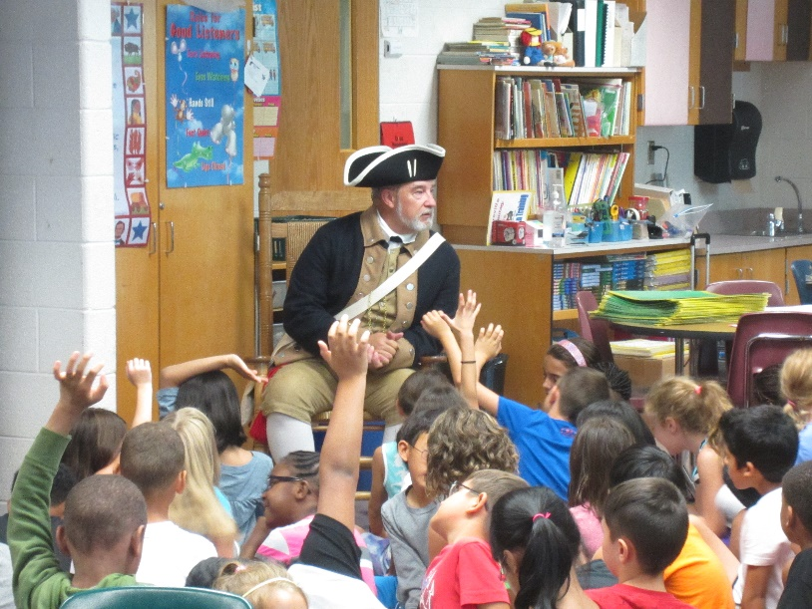
Appropriate Age Groups: 4th -12th grades, adults

Handouts: A master copy can be provided to make your own handouts or copies can be provided if copy fees are reimbursed.

Travel Range: The Charlotte area of North and South Carolina preferred, but can travel throughout the two states and north Georgia.

Fees: No fees for schools, non-profits, veterans or civic groups. Will consider fees to cover expenses that are outside a 100 mile travel radius.

Resources: Brooks has an extensive personal library of books on the revolutionary war and the colonial era. All presentations are thoroughly researched using primary and secondary sources. He has visited all the battlefields he lectures on and can provide the perspective of having stood the ground where the actual events occurred. All presentations conclude with a list of the research sources used.

.

