Mike & Cilla Tomme

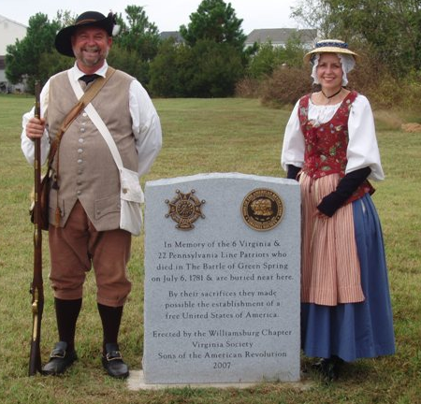
Contact Information:
Address: 3830 Chardonnay Drive, Rockledge, FL 32955
E-mail: mtomme@bellsouth.net
Home Telephone: (321) 806-3564
Cell Phone: (404) 312-9649
SAR Chapter: Marquis de Lafayette, Fayetteville
State Society: Georgia

Experience: Mike retired from the State of Georgia, Department of Administrative Services in the Risk Management Department with 35 plus years of service. Cilla retired from the Board of Regents, University System of Georgia with 38 years of service with a background in Fiscal Affairs and Human Resources. Mike has held several positions within the SAR at all levels, including the Chapter, State and National.

Lecture Topics/Period Attire Clothing: Mike and his wife Cilla lecture on Colonial Living. Their living history programs includes discussions of colonial era artifacts with their “traveling trunk” which contains such items as toys, household items, Indian trading goods, and soldiers’ military accessories. They also discuss the uniforms of the day for men and clothing for women. Mike can also provide a demonstration of his Long Lander Brown Bess Musket (with prior appropriate approval from the group). Both appear in colonial attire which has been created by Cilla.

Specialty Lecture Topics: Colonial living during the American Revolutionary War, Colonial Women’s Dress, Education in the Colonial Period and other related topics. Militia uniforms and Continental Uniforms. We can develop other topics with advanced notice. Militia soldiers and their uniforms.

Lecturing Credentials: Routinely presented programs for 3rd thru 8th grade students, home schooled, church groups, senior citizen groups, civic groups and lineage societies (Sons of the American Revolution, Daughters of the American Revolution, Daughters of American Colonists, Colonial Dames Seventeenth Century, Daughters of War of 1812, etc.). Youth Protection Training Certified by the Boy Scouts of America.

Presentation Requirements: need a 6-8 ft. table for display of materials, room which allow participants to see and participate in presentation, no restriction on group size. Would need permission to bring Brown Bess Musket and saber on school property for school programs. If permission was granted could show how to load and fire musket in outdoor setting.

Audio-Visual Equipment: Would need a screen for my projector. Microphone/speaker system should be provided if desired.

Length of Program: Min. 45 min. Max: 1 ½ Hr.

Appropriate Age Group: 4th -8th grades, adults

Handouts: Master copy can be provided to make own handouts or copies can be provided if copy fees are reimbursed. Will provide a map of Colonial Georgia during the Revolution and Colonial paper money.,

Travel Range: Will travel outside state of Georgia and Florida.

Fees: No fees for Schools/Scouts, Home Schooled, Senior Citizen Groups, Civil groups, Heredity Societies, Church groups-Will consider fees to cover expenses that are outside a 100-200 mile radius / others – Please contact us for information.

Awards: Both Mike and Cilla have been recognized by the Daughters of the American Revolution for their involvement in the community with their Colonial Living Program. They both have been awarded the DAR Community Service Award with Pin.

Cilla has been recognized by the National Society of Colonial Wars for her program “18th Century Colonial America’s Women’s Clothing”. Her program was recognized as the National Winner for Patriotic Education. She has received the Nancy Hart Award for educational outreach by the Georgia Society, Sons of the American Revolution.

Resources: Collector’s Illustrated Encyclopedia of the American Revolution, George C. Neumann & Frank J. Kravic; Sketch Book 76, the American Solider 1775-1781, Robert L. Klinger; The Revolutionary Solider 1775-1783, C. Keith Wilbur; Soldiers of the American Revolution, Don Troiani; Brown Paper School USKids History: Book of the American Revolution, Howard Egger-Bovet & Marlene Smith-Baranzini; Tidings from the 18th Century, Beth Gilgun; Women’s Dress During the American Revolution, An Interpretive Guide, Brigade of the American Revolution; What Clothes Reveal; Linda Baumgarten; What Shall I Wear, A Guide to Assembling a Woman’s Basic 18th Century Wardrobe, Mara Riley; Costume Close-up Clothing Construction and Pattern 1780-1790, Linda Baumgarten & John Watson; Revolutionary Mothers, Carol Berkin.

