Click or tap here to enter text.
Lawrence (Larry) A. Flint
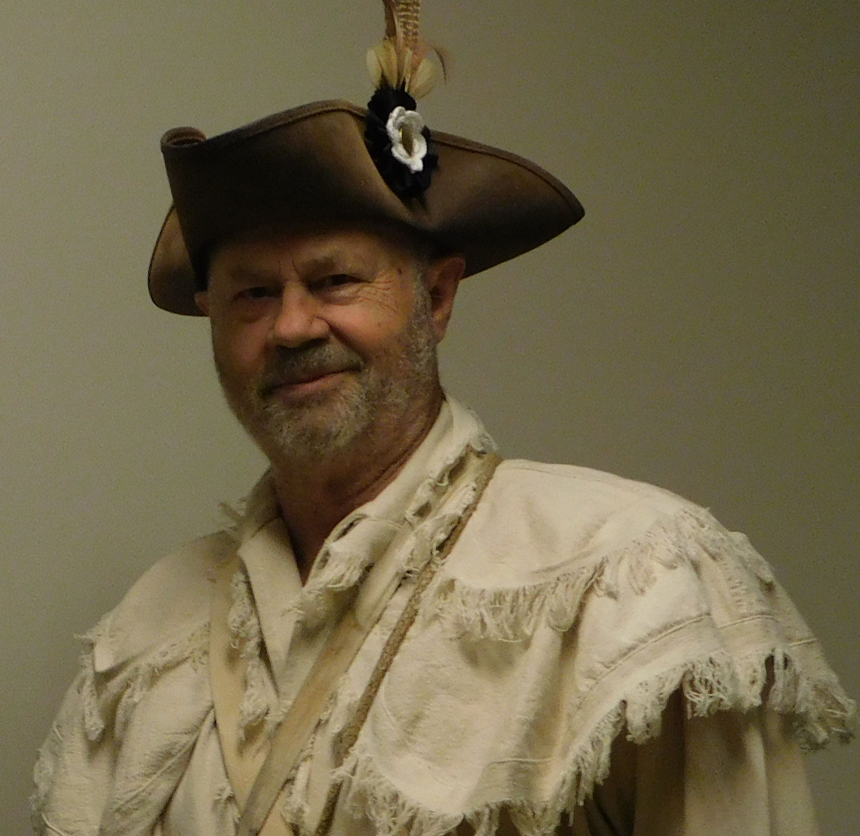
Contact Information:
Address: 153 MacArthur St., Richland, WA 99354

E-mail : thestone7@outook.com

Home Phone: 509-375-3001

Cell Phone: Click or tap here to enter text.

SAR Chapter: Mid-Columbia

State Society: Washington

Experience:

Four years

Lecture Topics/Costumes:

A Day in the Life of Colonial Times, various SAR Information/Display tables; wearing minuteman garb.

Specialty Lecture Topics:

Click or tap here to enter text.

Lecturing Credentials:

N/A

Presentation Requirements:

Traveling Trunk

Audio-Visual Equipment:

None

Length of Program:

Various

Appropriate Age Groups:

Kids to Adults

Handouts:
N/A

Travel Range:

Local - Washington

Fees:

None

Resources:

Traveling Trunk and personal equipment, including 1766 Charleville Musket

