Scott G. Giltner
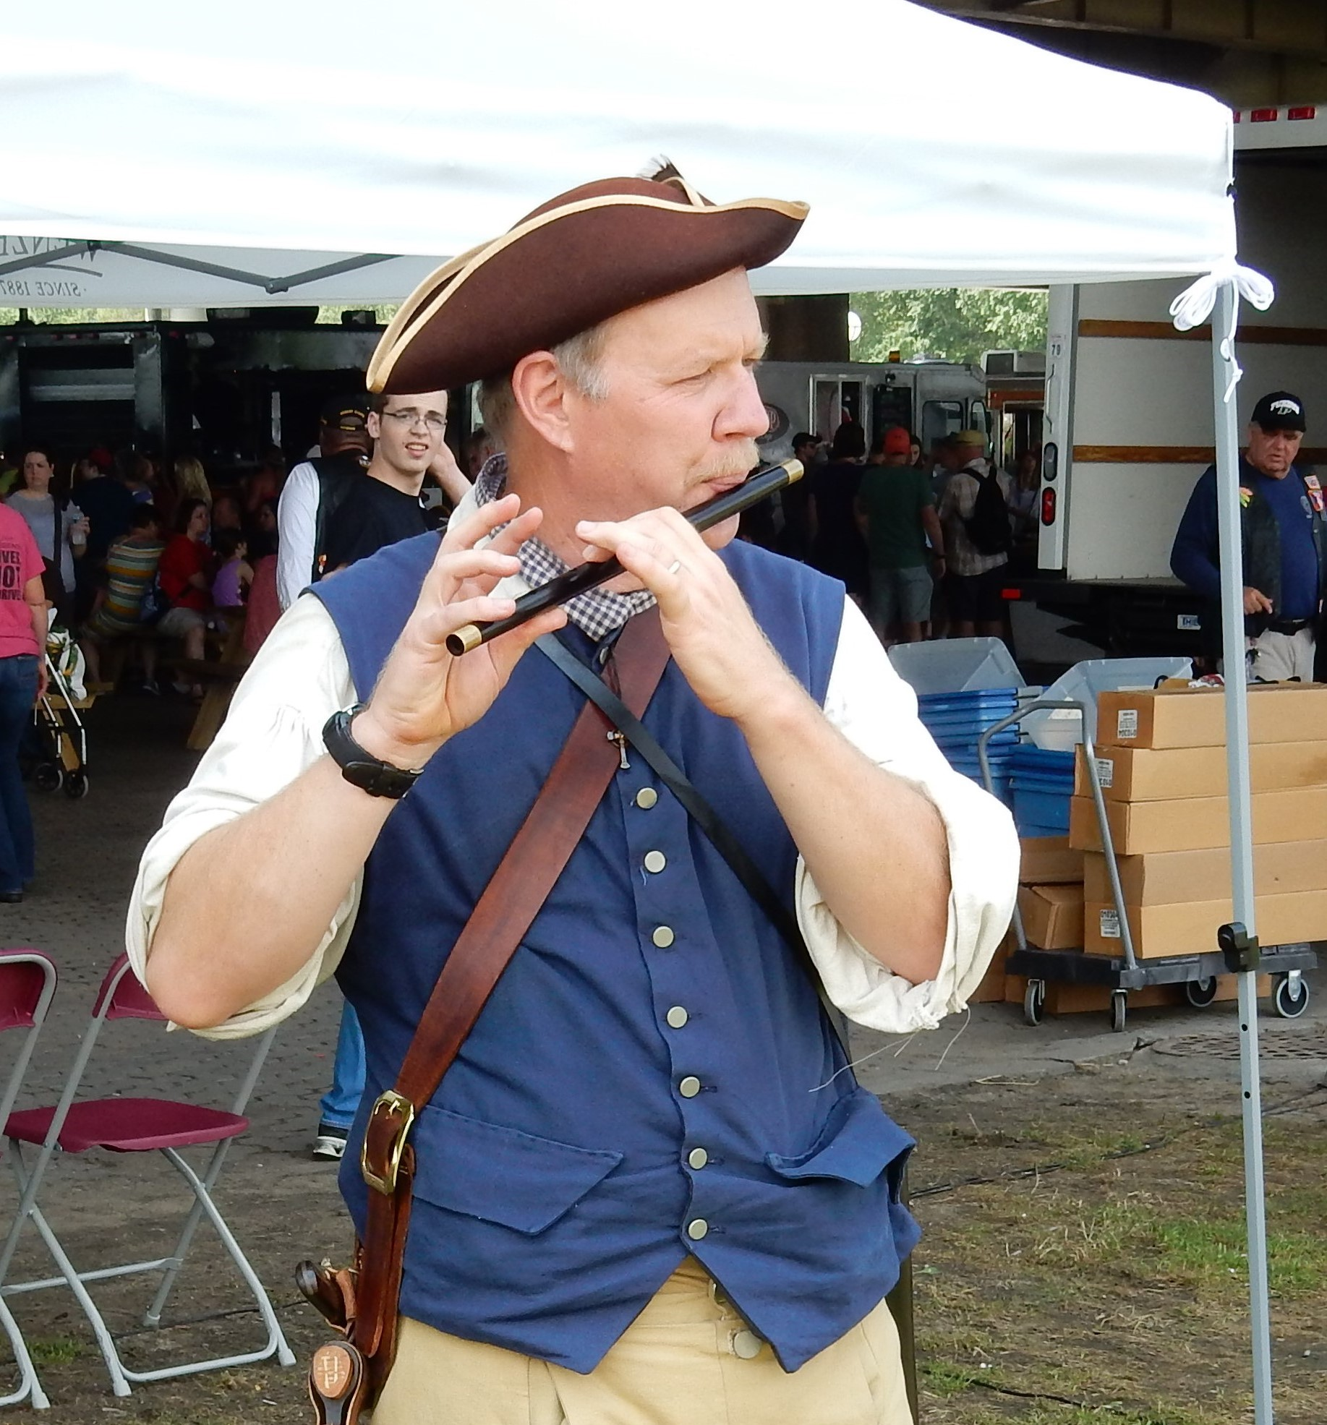
Contact Information:
Address: 605 Dorsey Way, Louisville, KY 40223

E-mail: stgilt@earthlink.net

Home Phone: 502-426-5881

Cell Phone: 502-649-4534

SAR Chapter: Gov Isaac Shelby

State Society: Kentucky

Experience:

Scott is an engineer with a B.S., M.S., and Ph.D. in engineering. He is currently employed by Dyno Nobel and travels across North America, and periodically, overseas. He has taught various university courses both as a graduate student and as a post-doctoral fellow. He has provided numerous presentations both as part of his employment and as a member of the SAR. Being a resident of Louisville, he is frequently called upon to provide presentations at SAR HQ for Outreach Education. He has held positions within the SAR at various levels, including Treasurer of the Central District, State Society Vice President and Asst. Treasurer, Chapter President, Veterans Committee Chairman, and Kentucky Society Color Guard Commander.

Lecture Topics/Costumes:

The presentations are given while dressed in either period civilian clothing or American Revolution period militia clothing.

Colonial Surveying
Military Music of the Revolutionary War
History of the American Flag
Battle Flags of the American Revolution
The Star Spangled Banner, Its History and Meaning
Flag Etiquette and Flag Folding
Parts of the Flag
The Revolutionary War in the South
Fire Starting with Flint & Steel
Writing with Quill Pens and Ink
Spanish and French Exploration in North America
Causes of the American Revolution
Weaponry of the American Revolution
Battle Tactics – Old World versus New World
The Great Wagon Road and the 1st Major American Migration

Specialty Lecture Topics:

Colonial Surveying
Military Music of the Revolutionary War
History of the American Flag
Battle Flags of the American Revolution
The Star Spangled Banner, Its History and Meaning
Flag Etiquette and Flag Folding

Lecturing Credentials:

Scott has routinely presented programs for 2nd thru 12th grade students, home schooled, church groups, civic groups and lineage societies (Sons of the American Revolution, Daughters of the American Revolution, Children of the American Revolution, and Dutch Cousins). He is also a regular presenter for Outreach Education at SAR HQ. He is Youth Protection Training Certified by TrailLife USA.

Presentation Requirements:

Typical requirement is an area large enough for the audience. Presentations can be given indoors or out. Special presentation requirements are listed below.

Colonial Surveying – large area (indoor or outdoor) where running a chain can be simulated.
The Star Spangled Banner, Its History and Meaning – a projector and screen are helpful but not required.
Fire Starting with Flint & Steel – outdoors only.
Writing with Quill Pens and Ink – area for writing where spilled ink will not be a concern.
Weaponry of the American Revolution – venue must allow flintlock firearms and edged weapons on site.
Battle Tactics – Old World versus New World – venue must allow flintlock and edged weapons on site.
The Great Wagon Road and the 1st Major American Migration – projector and screen are helpful for large audiences.

Audio-Visual Equipment:

For presentations listed above that require a projector, a projector and screen will be required.
Colonial Surveying – surveying equipment is provided as part of the presentation.
For the various flag presentations all the required flags are provided as part of the presentation.

Length of Program:

Colonial Surveying (20-30 minutes)
Military Music of the Revolutionary War (5-15 minutes)
History of the American Flag (10-15 minutes)
Battle Flags of the American Revolution (15-20 minutes)
The Star Spangled Banner, Its History and Meaning (45-70 minutes)
Flag Etiquette and Flag Folding (10-30 minutes)
Parts of the Flag (14 minutes)
The Revolutionary War in the South (30 minutes)
Fire Starting with Flint & Steel (5-10 minutes)
Writing with Quill Pens and Ink (15 minutes)
Spanish and French Exploration in North America (20-30 minutes)
Causes of the American Revolution (20-30 minutes)
Weaponry of the American Revolution (15-30 minutes)
Battle Tactics – Old World versus New World (20 minutes)
The Great Wagon Road and the 1st Major American Migration (20 minutes)

Appropriate Age Groups:

Many presentations can be adjusted to properly engage the age group.

Colonial Surveying (Ages 7 and up)
Military Music of the Revolutionary War (Ages 5 and up)
History of the American Flag (Ages 5 and up)
Battle Flags of the American Revolution (Ages 5 and up)
The Star Spangled Banner, Its History and Meaning (Ages 8 and up)
Flag Etiquette and Flag Folding (Ages 6 and up)
Parts of the Flag (Ages 10 and up)
The Revolutionary War in the South (Ages 10 and up)
Fire Starting with Flint & Steel (Ages 8 and up)
Writing with Quill Pens and Ink (Ages 6 and up)
Spanish and French Exploration in North America (Ages 8 and up)
Causes of the American Revolution (Ages 8 and up)
Weaponry of the American Revolution (Ages 8 and up)
Battle Tactics – Old World versus New World (Ages 10 and up)
The Great Wagon Road and the 1st Major American Migration (Ages 8 and up)

Handouts:

The Star Spangled Banner, Its History and Meaning – the Star Spangled Banner lyrics, Baltimore harbor maps.
Flag Etiquette and Flag Folding – The American Flag, History and Etiquette.
Parts of the Flag – diagram labeling parts of the flag along with a ‘fill in the blank’ test.

Travel Range:

Anything within a two hour drive of Louisville, KY. Will travel further for special events.

Fees:

None. Will except travel expenses.

Resources:

Geodaesia Or, The Art of Surveying and Measuring Land Made Easie, John Love, 1720.
The Practical Surveyor, John Hammond, 1765.
Standards and Colors of the American Revolution, Edward Richardson, 1982.
Military Music of the American Revolution, Raoul F. Camus, 1975.
Military Music of the American Revolution, A collection of Authentic Signals, Camp Duties, Marches, and Favorite Airs for the Fife and Drum, Brigade of the American Revolution, 2007.
Music for Patriots, Politicians, and Presidents, Vera Lawrence, 1975.
The Pennsylvania – Kentucky Rifle, Henry Kaufman, 2005.
The Long Rifle, Robert Lagemann and Albert Manucy, 1993.
The Great Wagon Road From Philadelphia to the South, Parke Rouse, 2008 (reprint).
& numerous other books.

