Emil Decker
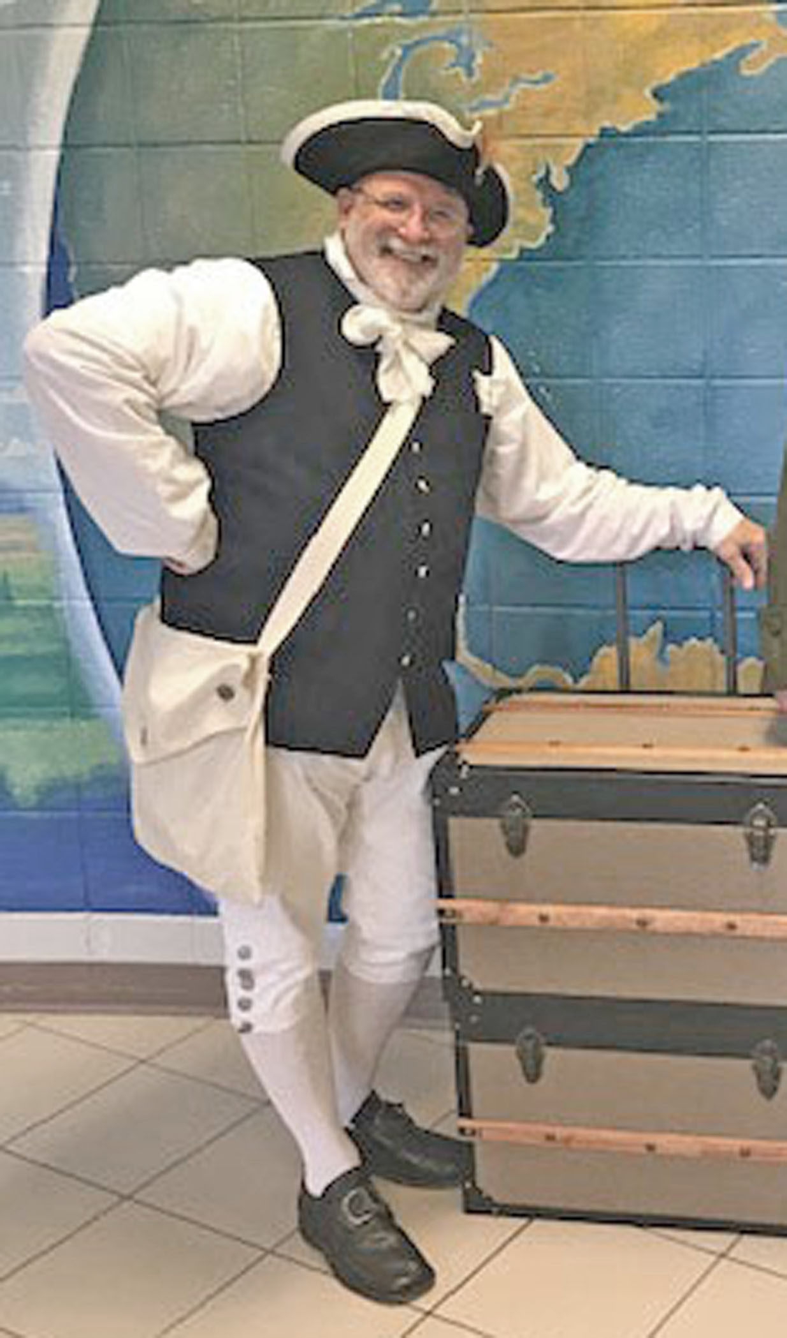
Contact Information:
Address: 480 Grizzle Rd, Dawsonville, GA 30534

E-mail: eldecker@weegrr.com Alt. : eldecker@windstream.net

Home Phone: (706) 216 - 5015 (Leave msg if no answer)

Cell Phone: (706) 482 - 8248

SAR Chapter: Robert Forsyth

State Society: Georgia

Experience:

Retired Education Specialist, public speaking, Reenactor, Editor of multiple newsletters

Lecture Topics/Costumes:

Traveling Trunk: 18th century frontier life, weapons, clothing, tools, toys, trade, etc. Hands on, pass around items preferred. / Militia, Continental,

Specialty Lecture Topics:

Willing to research specific topics of interest to groups; Past topics: Marquis de Lafayette; Kings Mt.; Period Medical Procedures; Counties of Georgia named for Rev. War Individuals, Etc.

Lecturing Credentials:

BSed Univ. of Georgia, Speech Communications/English/Drama, Industrial Arts: MSed Univ of Georgia, Computer Based Ed.:
Specialist in Ed. Lesley University, Online / Distance Learning: 32 years teaching.

Presentation Requirements:

Depends on presentation. Hands-on, props, and/or A/V.

Audio-Visual Equipment:

Laptop, Projector, screen as available. Speaker system as needed for audience/room.

Length of Program:

15 – 45 min. depending on audience, subject, & interaction

Appropriate Age Groups:

Any. All. Presentations adapted to the group

Handouts:

Generally not. Can be developed as needed / requested.

Travel Range:

Have Presentation. Will Travel. Distance is no problem. (see fees)

Fees:

Distance, time involved, overnighters, all negotiable. No set fees, however expenses should be considered.

Resources:

Traveling Trunk, weapons, various depending on the presentation.

