Click or tap here to enter text.
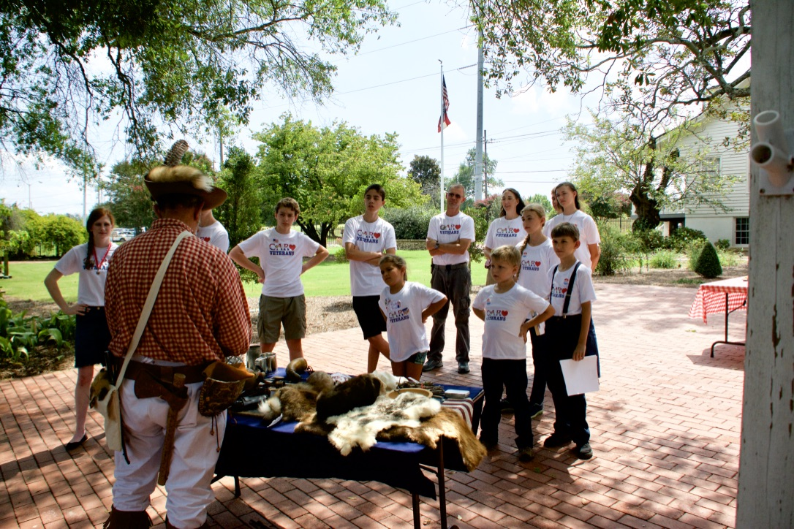
Contact Information:
Address: Bill Colbert

E-mail: whcolbert@aol.com

Home Phone: 706-860-3437

Cell Phone: 762-215-1072

SAR Chapter: Col. William Few

State Society: Georgia

Experience:

Not sure what this means, but I have been making these presentations for about five years. My wife, Pat, who is a DAR and past regent for her College Hill Chapter, often participates in these events with me.

Lecture Topics/Costumes:

Ours are most often simply a review of the time period, using the props from the chest as talking points. We do engage our audiences and often have them take part in the process by handing the items and asking questions as they do so. Pat is a musician and brings a Hammered Dulcimer with her, and plays for the audience and invites them to join her afterward for an up close and personal look at the instrument.

We are both always in costume.

Specialty Lecture Topics:

None

Lecturing Credentials:

No formal credentials.

Presentation Requirements:

We require no special location preparation other than a table and space to work with the audience. We had done classrooms, auditoriums and outdoor locations. The DAR chapters here in Augusta also manage Meadow Garden, a historic home of George Walton, here in Augusta. It is an outstanding venue, used most often by us when they have special seasonal tours.

Audio-Visual Equipment:

Typically, none are required.

Length of Program:

Classrooms programs run about an hour.

Appropriate Age Groups:

Typically, 4th and 8th grade, but it is not uncommon to have adult audiences such as church senior groups.

Handouts:

None at this time

Travel Range:

One hour

Fees:

None

Resources:

A “trunk’ funded by the GASSAR, our SAR/DAR chapters, and personal funds.

