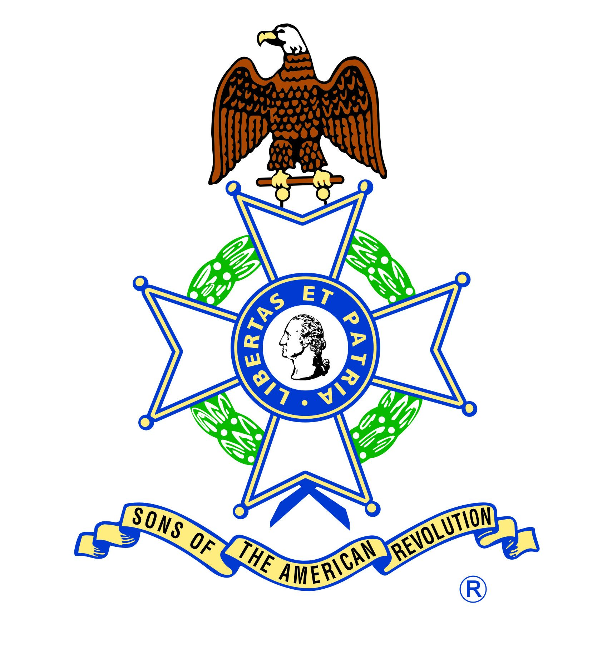

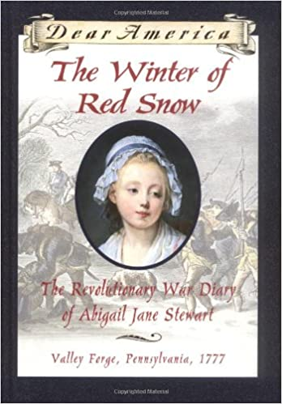Reading is Patriotic Elementary Level Recommended Reading List

The Winter of Red Snow: The Revolutionary War Diary of Abigail Jane Stewart, Valley Forge, Pennsylvania, 1777
By Kristiana Gregory
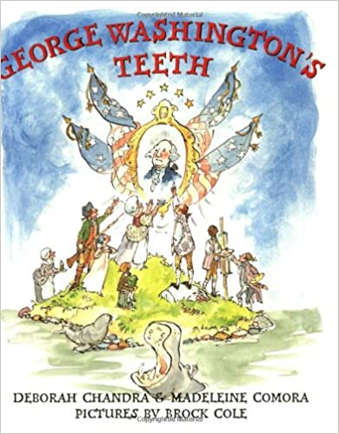(Age Range: 9-12, Grade Level: 4-6)

George Washington’s Teeth
By Deborah Chandra and Madeleine Comora
(Age Range: 4-8, Grade Level: PK-3)
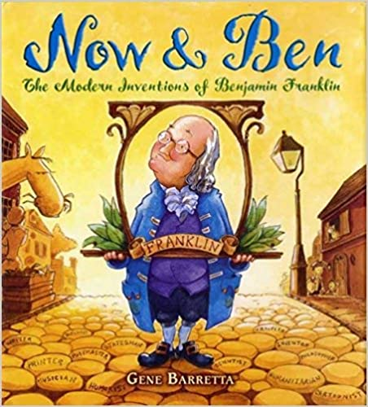

Now & Ben: The Modern Inventions of Benjamin Franklin
By Gene Barretta
(Age Range: 4-8, Grade Level: K-3)
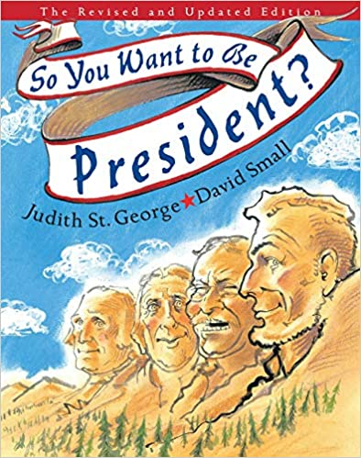

So You Want to Be President?
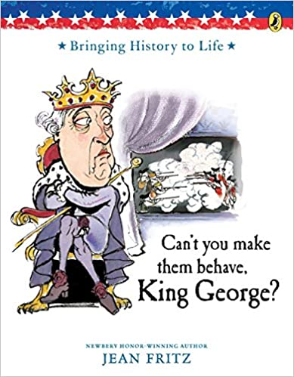By Judith St. George, illustrated by David Small
(Age Range: 7-10, Grade Level: 2-5)

Can’t You Make Them Behave, King George?
By Jean Fritz, illustrated by Tomie dePaola
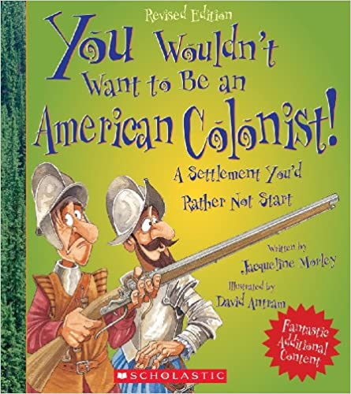 (Age Range: 7-10, Grade Level: 2-5)

You Wouldn't Want to Be an American Colonist!: A Settlement You'd Rather Not Start
By Jacqueline Morley, illustrated by David Antram
(Age Range: 8-11, Grade Level: 3-6)
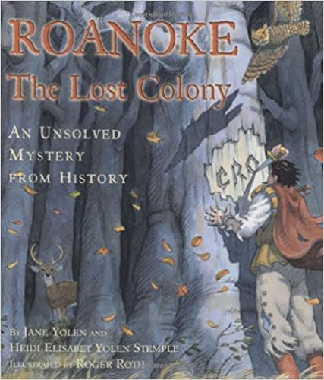 The Lost Colony of Roanoke
By Jean Fritz and Thomas Preston, illustrated by Hudson Talbott
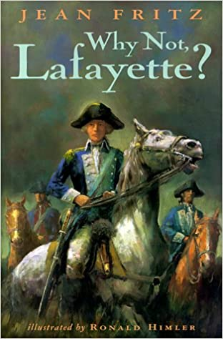(Age Range: 6-10, Grade Level: 1-5)

Why Not, Lafayette?
By Jean Fritz
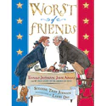(Age Range: 8-12, Grade Level: 3-7)

Worst of Friends: Thomas Jefferson, John Adams and the True Story of an American Feud
By Suzanne Tripp Jurmain, illustrated by Larry Day
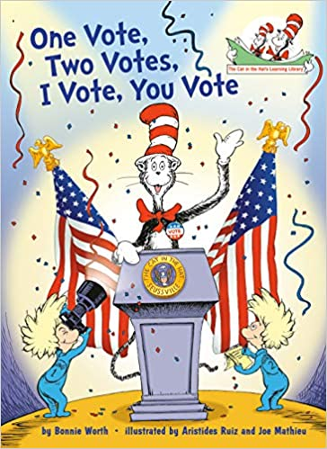 (Age Range: 6-8, Grade Level: 1-3)

One Vote, Two Votes, I Vote, You Vote
By Bonnie Worth, illustrated by Aristides Ruiz and Joe Mathieu
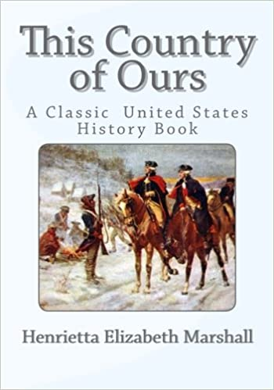(Age Range: 5-8, Grade Level: K-3)

This Country of Ours: The Story of the United States
By Henrietta E. Marshall
(Age Range: 7-10, Grade Level: 2-3)
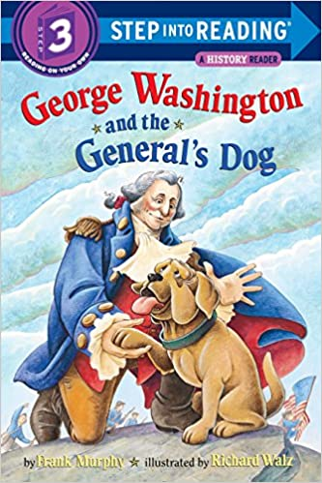

George Washington and the General’s Dog
By Frank Murphy
(Age Range: 5-8, Grade Level: K-3)
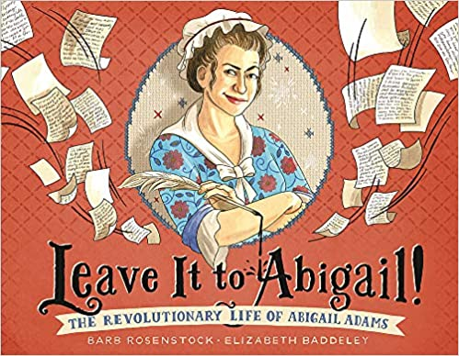
Leave it to Abigail!: The Revolutionary Life of Abigail Adams
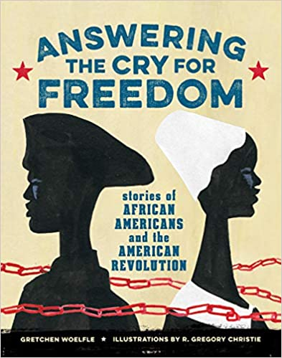 By Barb Rosenstock, Illustrated by Elizabeth Baddeley
(Age Range: 4-8, Grade Level: PK-3)

Answering the Cry for Freedom
By Gretchen Woelfle
(Age Range: 9-12, Grade Level: 4-7)
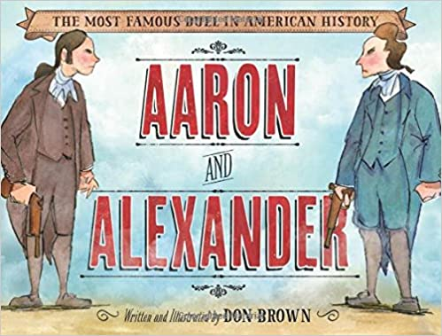 Aaron and Alexander: The Most Famous Duel in American History
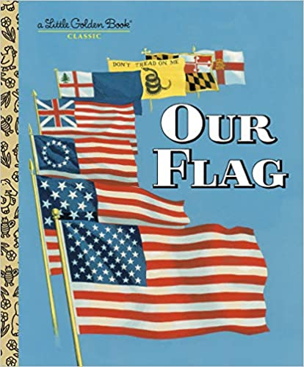 By Don Brown
(Age Range: 5-7, Grade Level: K-2)

Our Flag
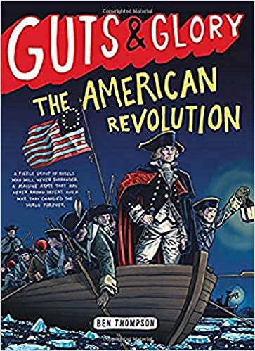By Carl Memling, Illustrated by Stephen Cook
(Age Range: 3-7, Grade Level: PK-2)

Guts and Glory: The American Revolution
By Ben Thompson
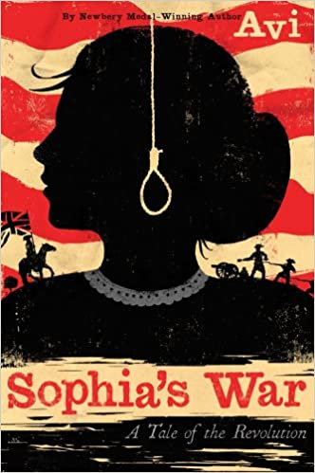 (Age Range: 8-12, Grade Level: 3-7)

Sophia’s War: A Tale of the Revolution
By Avi
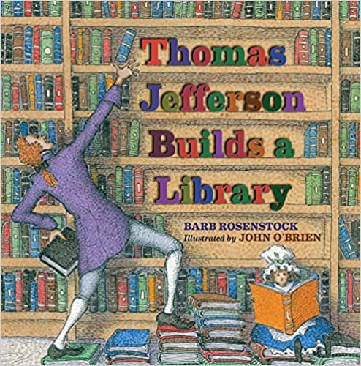(Age Range: 8-12, Grade Level: 3-7)

Thomas Jefferson Builds Library
By Barb Rosenstock, Illustrated by John O’Brien
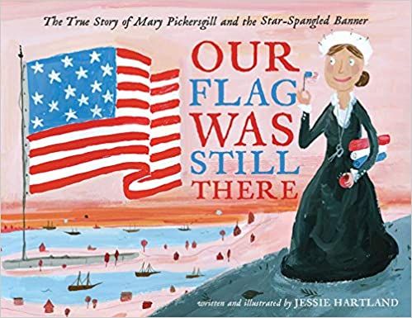 (Age Range: 8-12, Grade Level: 3-6)

Our Flag Was Still There: The True Story of Mary Pickersgill and the Star-Spangled Banner
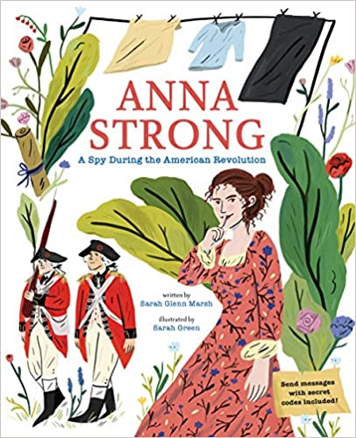By Jessie Hartland
(Age Range: 4-8, Grade Level: PK-3)

Anna Strong: A Spy During the American Revolution
By Sarah Glenn Marsh, Illustrated by Sarah Green
(Age Range: 4-8, Grade Level: PK-3)

The Seeds of America Trilogy: Chains; Forge; Ashes
By Laurie Halse Anderson
(Age Range: 10-14, Grade Level: 5-8)

Reading is Patriotic Certificate Program

Interested in earning a certificate for reading about American Revolution and Civics? Read three books on these topics and send the following information to cwilson@sar.org to receive a Reading is Patriotic certificate:

- Your full name
- School name
- Book titles and authors
- Home / email address where Reading is Patriotic Certificate should be sent

Send a photo/video of your child/student reading one of their patriotic books to cwilson@sar.org and we may feature it on the SAR website!

