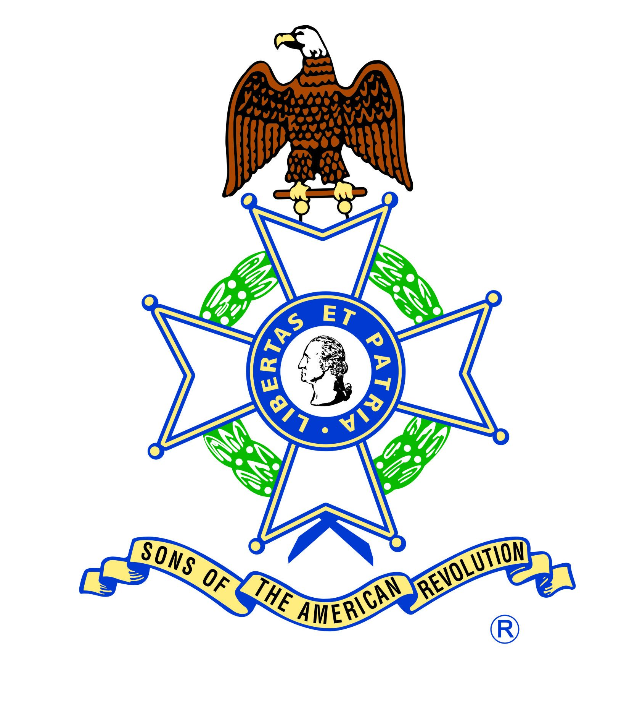

Design Your Own Flag

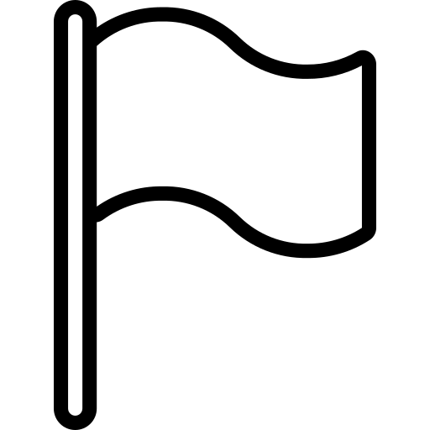

Colors

While these colors and their meanings are common,
scholars still debate the meanings behind
the colors appearing on flags.

Choose the color or colors and mark it with an X that says “This is me!”

___ White Peace, Purity

___ Red Blood, Bravery

___ Blue Truth, Sea, Sky

___ Green Hope, Landscape, Fertility

___ Black Grief, The People

___ Purple Royal Majesty, Justice

___ Orange Worthy, Ambition

___ Yellow Generous, Sun

Layout

Choose the layout and mark it with
an X that says “This is me!”

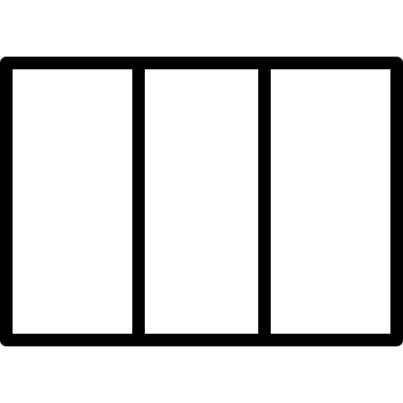
___
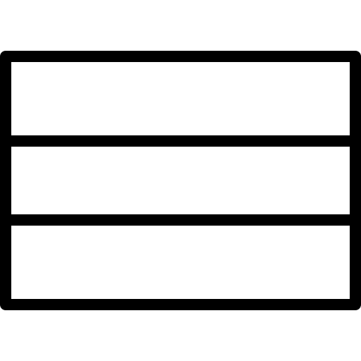
___

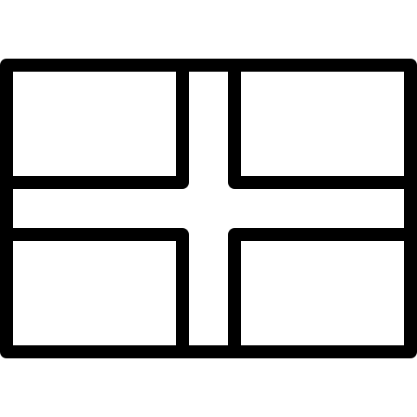
___

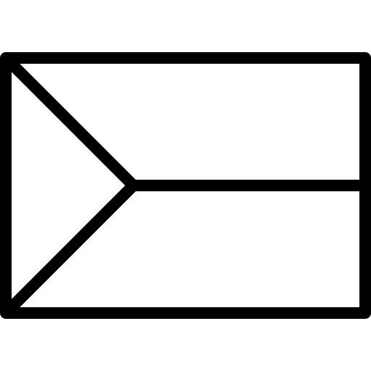
___

___


___

___

___ Other (Draw here)

Symbols

While these symbols and their meanings are common,
scholars still debate the meanings behind
the symbols appearing on flags.
Choose the symbol(s) and mark it
with an X that says “This is me!”


___ Sun Light. life


___ Moon New beginnings, eternity


___ Star Symbol of the heavens, parts of a nation
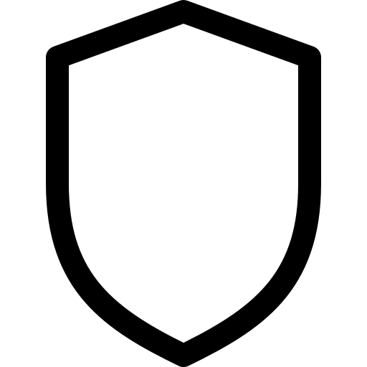

___ Shield Defense, protection

___ Cross Spirituality, Christianity

___ Other (Draw Here)

My Flag
Represents

______________ My Colors

______________ My Layout

______________ My Symbol

You now have everything you need to make your own flag. Go to the next page and use these symbols to show the world who you are!
Your Flag Design Here

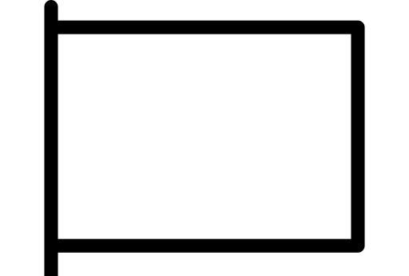

Online Resources

Here are some great websites to help you learn about flag designs online:

Make Your Own Flag
https://www.scholastic.com/parents/games/flag-maker.html

North American Vexillogical Association
http://www.nava.org

Flag Symbolism Explained, in 5 Infographics
https://bangordailynews.com/2016/07/01/living/flag-symbolism-explained-in-5-infographics/

