How to Marble Paper Like a Colonist

- Marbling paper began in Asia and arrived in Europe during the Renaissance, used for book bindings and decorative purposes
- Reached America in the 1760s, but did not become a widespread industry until the 19th Century
- Very specialized skillset that not many people possessed in the colonies
- However, Ben Franklin saw the benefits of using the paper as an anti-counterfeiting measure in printing currency
- In the May 10, 1775 printing of continental currency, marbling was used on the boarder to the $20 bill (Figure 1)
- Franklin set up a printing press in Passy, France. Towards the end the American Revolution some French loan agreements and promissory notes to the United States were printed there. These documents were marbled on the edges to ensure authenticity, although the marbling itself was done by an unknown Frenchman. These were printed in duplicate, one copy for the French government and one for Franklin, many of which are currently at the American Philosophical Society.
- Franklin’s grandson Benjamin Franklin Bache printed currency for the Bank of North America (precursor of the Bank of the United States) in 1789 using paper Franklin had acquired in France in 1779 and brought back to the U.S. in 1785 (Figure 2). This was during the “copper panic” when banks would not accept copper coins.

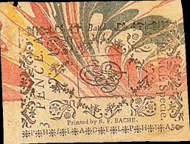
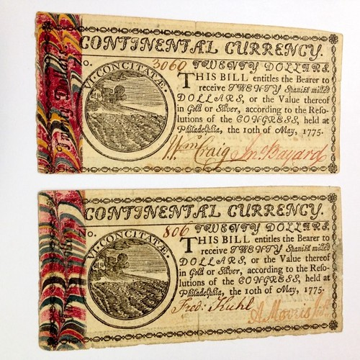

Figure 2 Philiadelphiafed.org Benjamin Franklin Bache currency

Figure 1 coinbooks.org

Supplies Needed:
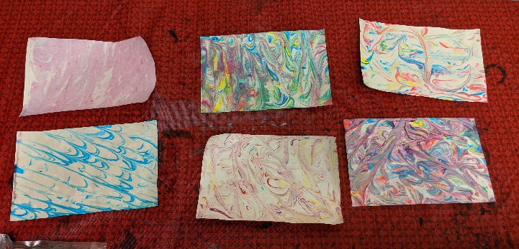
Flat aluminum pan or baking dish
Cardstock (Heavy weight paper)
Plain shaving cream (not the gel kind)
Food coloring or acrylic paint in assorted colors
Wooden popsicle/craft stick
Paper Towels
Clean, dry work surface
Small bucket of soapy water

Directions
(Roll up your sleeves to avoid getting any paint or food coloring on them.)
- Cover the bottom of your pan with shaving cream
- Squeeze droplets of paint and/or food coloring all over the shaving cream
- Take the craft stick and swirl it around the pan, mixing the colors up in a design of your choice
- Place the cardstock on top of the shaving cream, pressing gently to ensure that the whole paper gets covered in shaving cream
- Remove the paper from the shaving cream
- Scrape the excess shaving cream off the paper with the craft stick
- Let the paper dry
- Clean of your work-station of any paint, food coloring, or shaving cream

Quarantine Ideas for Using your Marbled Paper:
- Make a Greeting Card to send to a friend or family member
- Make Your Own Broadside to Announce House Rules During Quarantine
- Draw a colonial cartoon on the marbled paper

Resources:
https://www.philadelphiafed.org/-/media/publications/economic-education/ben-franklin-and-paper-money-economy.pdf
https://pastispresent.org/2016/good-sources/marbled-madness/
Wolfe, R. J., & Berger, S. E. (1990). Marbled paper its history, techniques, and patterns: with special reference to the relationship of marbling to bookbinding in Europe and the western world. Retrieved from https://books.google.com/books?id=kY92BMFNFjUC&pg=PA86&lpg=PA86&dq=marbled paper currency&source=bl&ots=VpTQOXIPvm&sig=ACfU3U1AquYmIqobejR2GkoOwMOrn1yI5w&hl=en&sa=X&ved=2ahUKEwjm8Lz7yKToAhWlAZ0JHbaQC_wQ6AEwFHoECGUQAQ#v=onepage&q=marbled paper currency&f=false

