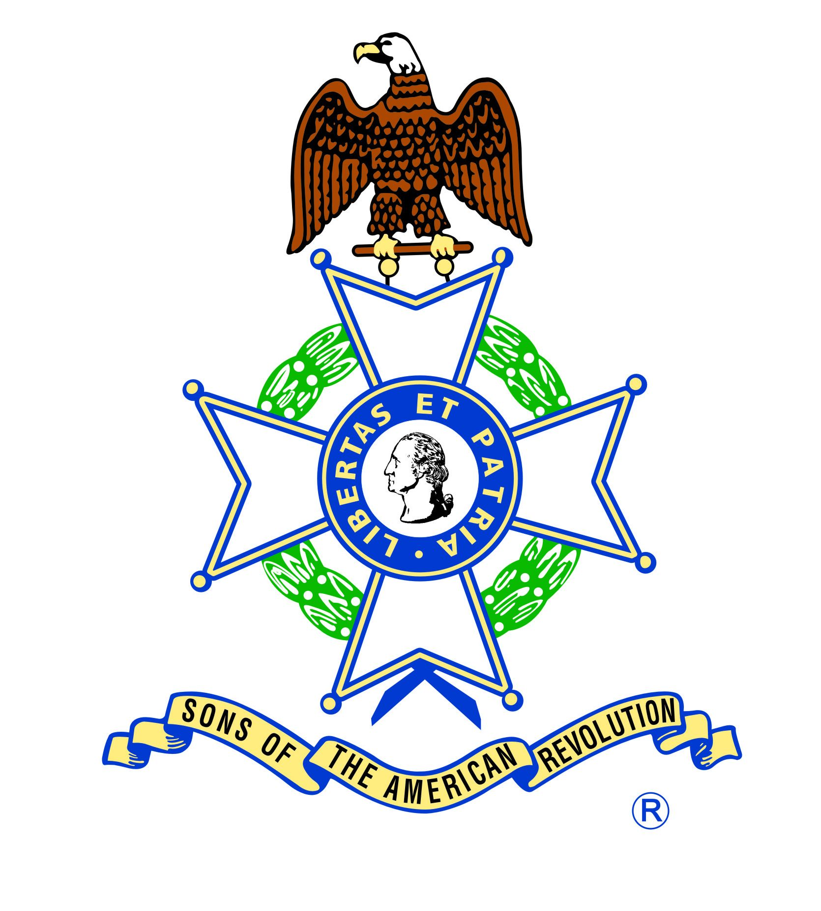

“I Spy” in the American Revolution

Opening Discussion Questions

What kind of people took part in spy rings?

What does a spy look like?

What does a spy do?

If you lived in the 18th century during the time of the Revolutionary War, would you have joined a spy ring?

Washington’s Thoughts on Spying
As commander-in-chief, Washington recognized the importance of intelligence, and he used all means possible to acquire and disseminate information. (Central Intelligence Agency, 2013)

Washington to Morris in January 1766: “There is nothing more necessary than good intelligence to frustrate a designing enemy, & nothing that requires greater pains to obtain” (U.S. Government Publishing Office, 1944, p. 268).

He instructed officers to monitor local newspapers and town gossip. By “comparing a variety of information,” he explained, “we are frequently enabled to investigate facts, which were so intricate or hidden, that no single clue could have led to the knowledge of them” (Founders Online, 2014).

Overview of Spying in the Revolutionary War:
  - Spying has gone on throughout all of history
  - Both the Americans and British used spies
  - Spies were very diverse (women, African Americans, British, Native Americans)
  - Types of information spies would transmit

Methods: (show examples)
- Cipher – A method for sending a coded message. Both the sender and recipient would need to know the code. Thomas Jefferson used a cipher wheel to send encrypted messages. This wheel was made of wooden disks. Each disk contained all alphabet letters on it. The order of the disks was the key the only he and the recipient knew. The wheel would be lined up until the intended message is spelled out, then Jefferson would write down any of the other rows of letters. The recipient would line up the secret code then look at all the other lines of text until one of the lines spelled out the secret message.
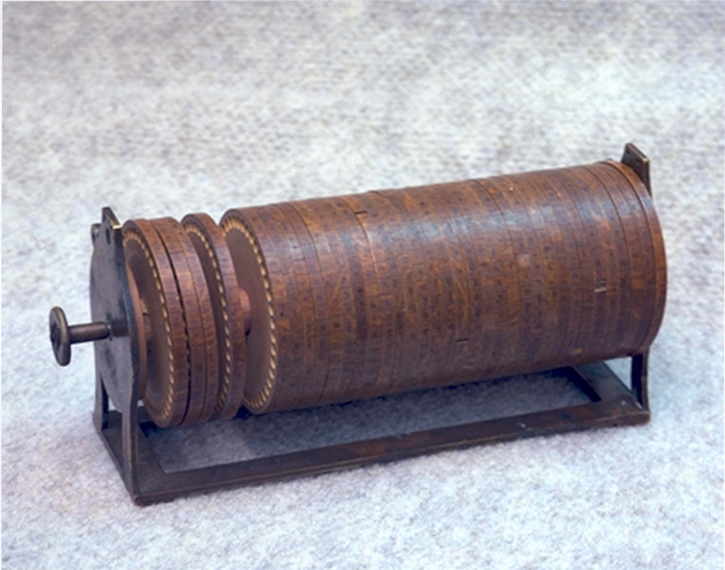
Thomas Jefferson’s Cipher Wheel
Wikipedia

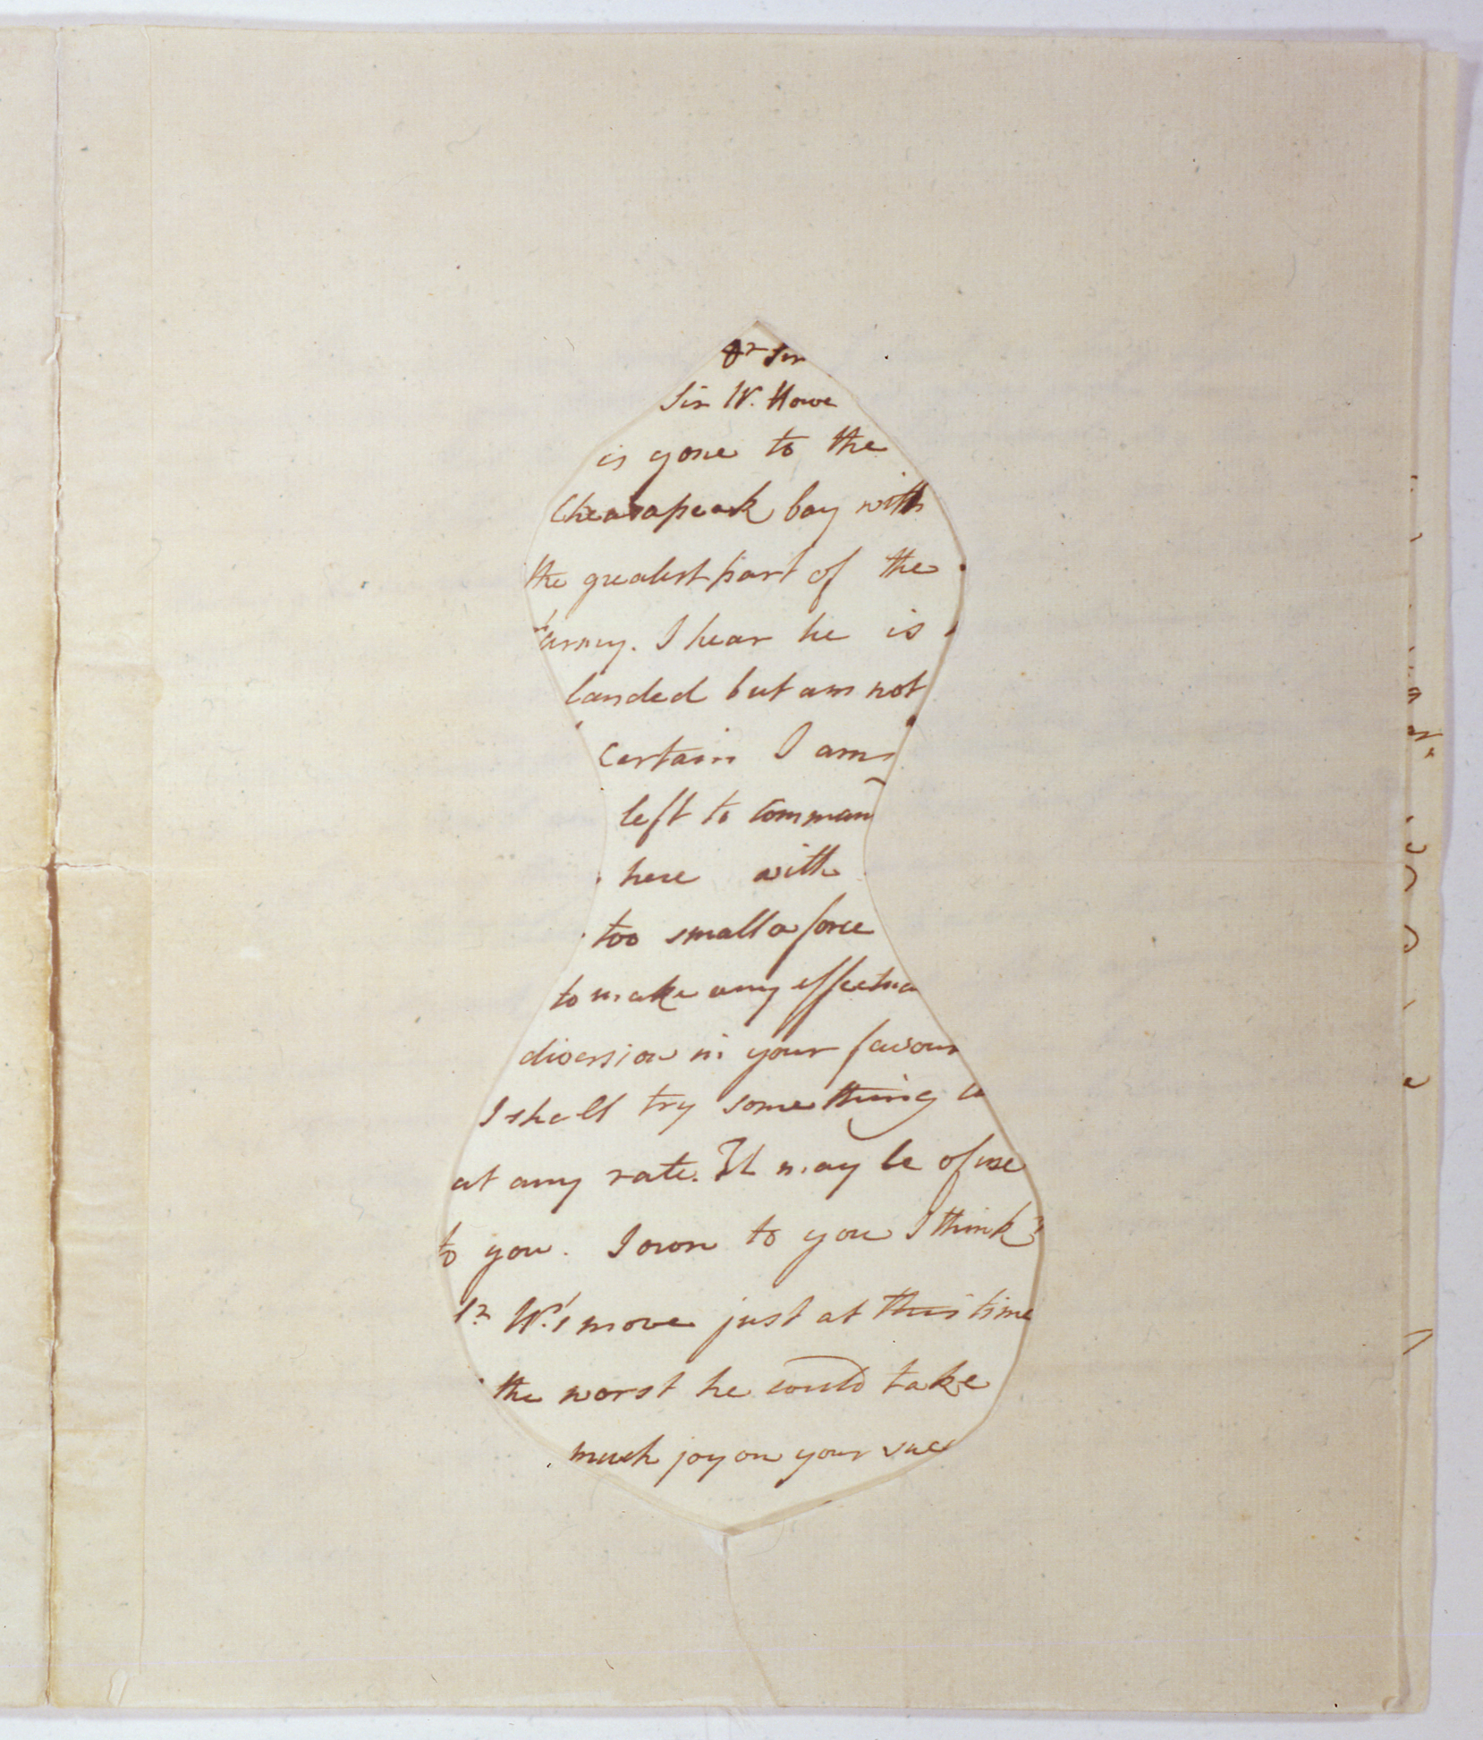
Mask and letter– these masks could be made of
many materials or shapes, unreadable without both pieces together, similar to a “reverse” fill-in-the-blank. The original letter appeared to be a normal letter, but once the mask was applied on top by the recipient, the secret message was revealed.

William Howe to John Burgoyne, 1777
William L. Clements Library

Quill Letter – hollowed out quill for tiny message strips
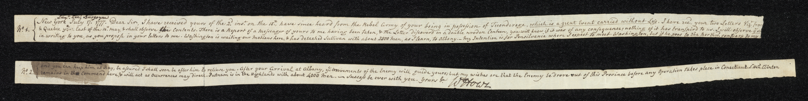

William Howe to John Burgoyne, 1777
William L. Clements Library

- Hollowed Bullets
- Small pieces of paper in each of the molds of coat buttons
- Hollowed Eggs
- Using the message as wadding paper between the gunpowder and the bullet in a “fowling piece”. If in danger, it can be fired and the message destroyed.
- Invisible Ink – Invisible Ink was made of ferrous sulfate and water.
They were deciphered by either placing over the flame of a candle, or by treating with a chemical such as sodium carbonate.
- Signals – Hand fans could be used as “fan language”. Depending on where the fan was held and how it was moved, secret signals could be sent. Hanging clothing out on a clothesline in certain orders could also create secret signals (see Culper Ring below).

Spy Profiles:
1. Nathan Hale
- Yale educated, became a schoolteacher
- Joined the 19th Connecticut Regiment
- One of the first known spies of the Revolutionary War
- Acted as a Dutch schoolmaster and went behind enemy lines to gather information
- Captured September 21, 1776
- Hanged the next day at the age of 21, common sentence for spying, seen as “ungentlemanly” by soldiers
- Famous for saying “I regret that I have but one life to give for my country.” However, we are not sure that this is what he said, it may have been inspired by the play Cato which said “What a pity it is/That we can die but once to serve our country” (The History Channel, 2014a)

2. The Paul Revere Gang
- First known American spy ring
- Approximately 30 “mechanics”
- Starting in 1775 they patrolled the streets of Boston. Each individual did it only about once every two weeks to not arouse suspicion.
- One drawback of this ring was that they all knew one another, which was against basic spying principles
- The spies often stole British artillery
- Warned of the battles of Lexington & Concord
- Paul Revere hung lantern in Old North Church (one lantern if the British were going by land, two if by water) to warn Colonel William Conant
- Revere spies involved Benjamin Church, first U.S. Surgeon General, part of Sons of Liberty and acquainted with Paul Revere, John Adams, Samuel Adams, and John Hancock
- Helped American wounded at the 1770 Boston Massacre and battle of Lexington, delegate of the Massachusetts Provincial Congress and Committee of Correspondence
- Frequently wrote to British about American supplies and troops in Boston, cipher letter discovered and court martial in late 1775, imprisoned for life (Congress had not yet authorized the hanging of spies), ill with asthma
- Exiled to the West Indies in 1780 but lost at sea

3. The Culper Ring
- Organized by Benjamin Tallmadge at the request of George Washington. Washington never knew the names of those involved.
- [Washington] asked William Duer, a member of the New York Committee for Detecting and Defeating Conspiracies of the New York Provincial Congress (and later became Governor of Kentucky) to recommend someone to be the agent. Duer recommended a colleague, Nathaniel Sackett. Washington appointed Captain Benjamin Tallmadge, a classmate and friend of Nathan Hale, to be Sackett's contact with the army. Sackett had developed some advancements and new methods for spying, such as keeping an agent in enemy territory and finding a means of regular communication, which he detailed in a letter to Washington on April 7, 1777, the date of Tallmadge's promotion. He discovered that the British were building flat–bottomed boats to use in a campaign against Philadelphia. Sackett had not produced enough correct intelligence fast enough for Washington, however, and he was soon paid and dismissed (Benjamin Tallmadge District, 2014)

- In order to safeguard the identity of his spies, Tallmadge utilized a number of protective measures. Tallmadge gave his informants pseudonyms and invented a numerical substitution system to identify his informants rather than use names. Seven hundred and sixty–three numbers were used, with 711 denoting General Washington, 745 representing England, and 727 for New York
- The ring would use elaborate codes and aliases as well as dead drops and invisible ink in the course of their activities.
- Robert Townsend (aka Samuel Culper Jr.) was the central figure and owned a dry goods store in NYC. He also was a writer for a local newspaper that sympathized with the British, thus making it seem as if he was a Loyalist. He often spoke with British soldiers as part of his newspaper job.
- Townsend would then give his information to the courier Austin Roe, who owned a tavern in Setauket as he was buying goods for people on Long Island.
- Roe would deliver an order from a John Bolton (Benjamin Tallmadge). Townsend would go up to his room, reply, and Roe would sneak to his room and hide the letter in his packages.
- Roe then rode 110 miles to Setauket, NY where he would bury the letter in a field he had rented for his cattle.
- This is present day equivalent of riding a horse from Louisville to Cincinnati.
- Abraham Woodhull (aka Samuel Culper Sr.) would pick it up. (known as a “dead drop”)
- He would look across the bay where a woman named Anna Strong would hang her laundry out on the line. A black petticoat would signal that Caleb Brewster had arrived in the bay to deliver the letter to Tallmadge. The number of handkerchiefs would indicate exactly where in the bay Brewster was hidden
- Tallmadge saw that the letter got delivered by mounted dragoons posted every fifteen miles to George Washington in New Windsor, NY. (Mount Vernon, 2014)

The success of this spy ring depended upon many people to work well. What do you think could have gone wrong along the way?
- storms, sickness, enemy scouts, horse issues, etc.

- The manner in which the ring operated was ingenious according to the conventions and limitations of the day. It was operated in such secrecy that even General Washington did not know the identity of many of the key players.
- Perhaps the group’s greatest achievement came in 1780, when it uncovered British plans to ambush the newly arrived French army in Rhode Island. Without the spy ring’s warnings to Washington, the Franco–American alliance may well have been damaged or destroyed by this surprise attack. The Culper Spy Ring has also been credited with uncovering information involving the treasonous correspondence between Benedict Arnold and John Andre (SpyMuseum.com, 2014).
- The messages had to go through 6 people, plus the dragoons before arriving to George Washington
- The Culper Ring members’ identities were not discovered until the 20th century.

4. Ann Bates
  - British spy
  - Teacher in Philadelphia
  - Posed as a peddler selling needles, thread, utensils to the American camps
  - When there she counted the men and supplies

5. Benedict Arnold
  - Most famous traitor in American history
  - Early in the war he led the American’s in capturing Fort Ticonderoga in 1775, surprise attack for American victory
  - His successful leadership also led to Gen. Burgoyne’s surrender at Saratoga on October 17, 1776.
  - Washington appointed him military commander of Philadelphia after the British evacuated in 1778
  - Arnold was a divisive figure here: the public thought he was corrupt, using public property and closing down all shops to make money for himself, and was too friendly with the British
  - He faced a court martial for corruption and resigned on March 19, 1779
  - Arnold then put in charge of West Point in 1780: Washington declared West Point, as “the most important strategic military position in America”. West Point is located in New York, along the Hudson River and 50miles from New York City. West Point was a very strategic point during the American Revolution, due to its location near the Hudson River and its geographical conditions for its defense (WestPoint.org, 2015)
  - He then became a spy for the British for the next few months until he was exposed when the British spy Major John Andre was captured. He was made a British brigadier and returned to England after the war.
  - Arnold was not trusted by British citizens later, knew of previous betrayal to Americans and wary of him
  - There is more than one way to look at a historical figures– US sees Arnold as a traitor, however the British look at him differently

6. James Armistead Lafayette
- Born into slavery in the mid 1700s
- Enlisted in army in 1781 with the permission of his owner William Armistead.
- Assigned to serve Marquis de Lafayette – leading the army in VA keeping an eye on the British army
- January 1781 Benedict Arnold commanding 1,600 British troops in VA
- British had captured Richmond, burned and destroyed towns, plantations, farms.
- Lafayette got Armistead into the British camp using the story that he was escaping in hopes of obtaining his freedom if he served with the British. Armistead assigned as an orderly and guide.
- British sent him out to spy on Patriots, common practice
- He was a double agent, gave the British bad information and gave accurate details of British plans to the Americans
- Cornwallis joined Arnold’s camp in May
- Armistead learned the British planned to strengthen Yorktown and gave this information to Lafayette & Washington
- This information helped Patriots hold up Cornwallis and get him to surrender Oct. 17, 1781. Marched out of camp on Oct. 20, 1781.
- End of war did not change Armistead being enslaved
- 1783 Virginia law promised freedom to slave-soldiers, not slave-spies
- In 1784 Lafayette learned that Armistead was still in bondage and urged state legislatures to free him
- In 1787, VA assembly freed Armistead and granted him a pension. Lived out his life in New Kent County, VA as a free man and farmer.
- As a way of thanking Lafayette, Armistead adopted Lafayette as his last name.

The Results of Espionage During the War

- most of the profiles that we have discussed survived through the War

- some like Nathan Hale and John Andre were hanged, a common solution

What else might happen to a spy?

- if caught they could be traded for other prisoners
- they might be offered to be a double agent
- spies might be interrogated for information

Before entering New York in triumph and “to ensure the safety of American spies in the city, Washington sent Benjamin Tallmadge on ahead to protect them against any reprisals as their identities became known” (Chernow, 2010, p. 449).

- we have covered only a few profiles using famous examples, but many spies remain unknown and forgotten

Do you think that this means that the unknown spies were successful?

Hands-On Activities:

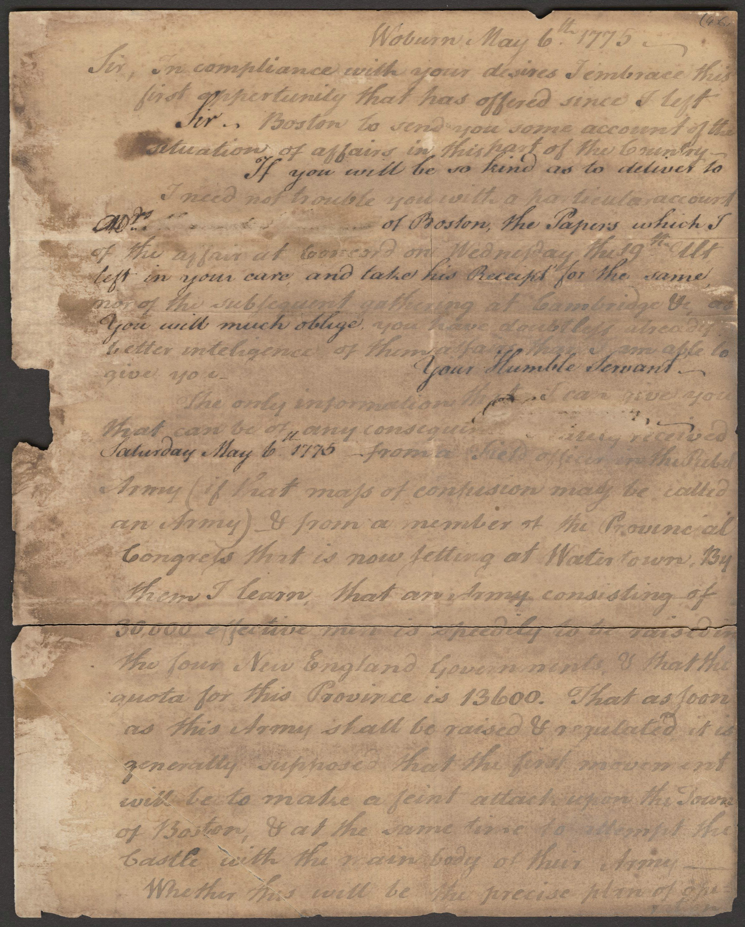
Write a Message with Invisible Ink:
Benjamin Thompson Letter
William L. Clements Library
- Divide students into 2 groups
- Using a cotton swab, write a secret message in vinegar (“Victory or Death” – George Washington, “Give me Liberty or Give me Death” – Patrick Henry)
- Let the message dry while station continues
- At the end of the station, have the 2 groups trade messages
- Using a cotton swab, wipe all over the paper with grape juice concentrate.
- The secret message should appear lighter than the rest of the paper (Helmenstein, 2014; WikiHow.com, 2014).

Decode a Secret Message Using a Cipher Wheel:

Make a cipher wheel (Directions here)
Write a secret message with a cipher wheel. Trade secret message with classmate and decode each other’s messages.
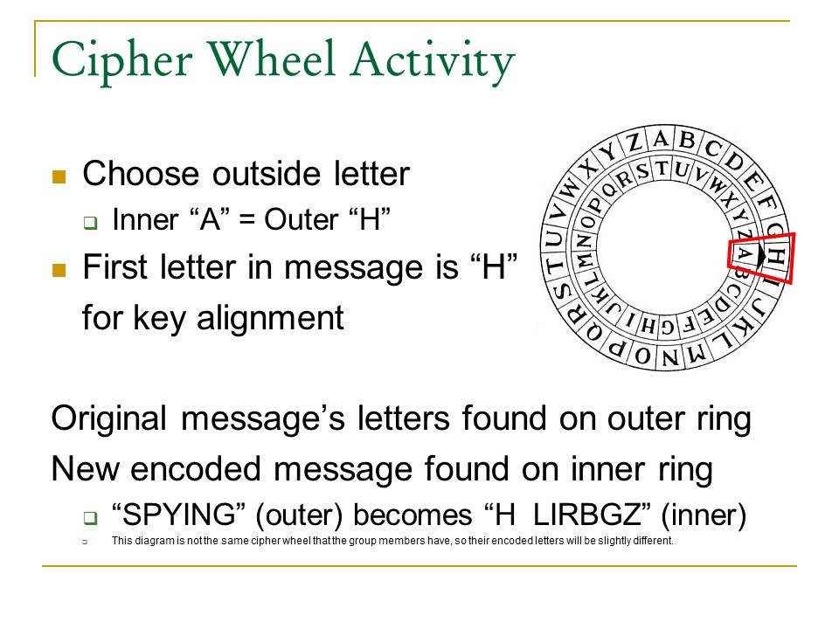

Decode a Message Using Culper Spy Ring’s Secret Code

Give students a secret message written using words in the Culper Spy Ring Code Book. Give students a copy of the code book and have them decode the message.

Here are some examples:

711 283 282 736 (George Washington is in New Jersey)
135 441 730 (Dragoon obstruct Kingsbridge)

Bibliography

American Movie Classics. (2014). Spy tools of the American Revolution. Retrieved on 3 December 2014 from http://www.amctv.com/shows/turn/spy-tools-of-the-american-revolution

Bakeless, J., & Bakeless, K. L. (1962). Spies of the Revolution. New York: Scholastic Book Services.

Bakeless, J. (1998). Turncoats, traitors, and heroes. New York: Da Capo Press.

Benjamin Tallmadge District. (2014). Who was Benjamin Tallmadge?. Retrieved on 3 December 2014 from http://btdistrict.org/id124.htm

BlackPast.org. (2015). Lafayette, James Armistead (1760-1832). Retrieved on 8 January 2015 from http://www.blackpast.org/aah/lafayette-james-armistead-1760-1832

Central Intelligence Agency. (2013). History of American intelligence. Retrieved on 3 December 2014 from https://www.cia.gov/kids-page/6-12th-grade/operation-history/history-of-american-intelligence.html

Chernow, R. (2010). Washington: A life. New York: The Penguin Press.

Foster, K., Ghering, C., Light, M., McCollum, M. (1999). Spy letters of the American Revolution: From the collections of the Clements Library. Retrieved on 3 December 2014, from http://clements.umich.edu/exhibits/online/spies/index-main2.html

Founders Online. (2014). From George Washington to James Lovell, 1 April 1782. Retrieved on 4 December 2014 from http://founders.archives.gov/documents/Washington/99-01-02-08065

Hagist, Don. (2020). How to Write Like a Revolutionary War Spy. Journal of the American Revolution.

Helmenstine, A. M. (2014). How to make invisible ink - baking soda. Retrieved on 3 December 2014 from http://chemistry.about.com/cs/howtos/ht/invisibleink2.htm

The History Channel. (2014a). Nathan Hale volunteers to spy behind British lines. Retrieved 3 December 2014 from http://www.history.com/this-day-in-history/nathan-hale-volunteers-to-spy-behind-british-lines

The History Channel. (2014b). The Culper spy ring. Retrieved on 4 December 2014 from http://www.history.com/topics/american-revolution/culper-spy-ring
James F. Justin Museum. (1998). Doctor Benjamin Church: American Revolutionary War rebel patriot and English spy. Retrieved on 20 January 2015 from http://www.jfjcccmuseum.com/tjoschultz/church.html
Mount Vernon. (2014). Culper spy ring. Retrieved on 3 December 2014 from http://www.mountvernon.org/research-collections/digital-encyclopedia/article/culper-spy-ring/

Rose, A. (2007). Washington's spies: The story of America's first spy ring. New York: Bantam Dell.

SpyMuseum.com. (2014). The Culper spy ring. Retrieved on 3 December 2014 from http://spymuseum.com/major-events/spy-rings/the-culper-spy-ring/

U.S. Government Publishing Office. (1944). George Washington to Robert Hunter Morris, 5 January 1766 from The Writings of George Washington, 1931–1944, Volume I.

U-S-History.com. (2015). Benjamin Church. Retrieved on 20 January 2015 from http://www.jfjcccmuseum.com/tjoschultz/church.html

Weigold, M. E. (2004). The Long Island Sound: A history of its people, places, and environment. New York: NYU Press.

WestPoint.org. (2015). West Point facts. Retrieved on 19 January 2015 from http://www.west-point.org/parent/wppc-ne-ohio/WP-facts.htm

WikiHow.com (2014). How to make an invisible ink message. Retrieved 3 December 2014 from http://www.wikihow.com/Make-an-Invisible-Ink-Message

