Objectives
The objective is to increase awareness of both the SAR and significant historical events by having proclamations issued by selected governing bodies based on the significant events as outlined by the 250th Committee.
Target Audience and Distribution
Governing bodies that have the ability to issue proclamations. This would include State Legislators, Cities, Chambers of Commerce, and State Board of Education. There may be more based on the locale.
Once obtained the proclamation could be sent to school districts or individual schools themselves. These could be circulated among SAR members at the State or Chapter level. The proclamation could also be posted on social media as well as press releases developed for print media.
National could pick a small number of events and decide a nationwide push was warranted.
Implementation
The proclamation will include factual information about the founding and objectives of the SAR and the mission statement.
Compile facts of the event that the proclamation is being issued to cover. Determine the title and the date of the proclamation. Sample facts and a sample proclamation are included.
Access the website of the governing body that has been selected for issuance of the proclamation. Locate their request form or the instructions for submission of the request for them to issue proclamation. This can be done through a Google search, “city of ________ proclamation request form”. Cities and counties are able to create ceremonial documents. State legislators are as well.
Sample copies are attached. Sample proclamations are also attached.
The search result most likely will reveal the instructions for submitting the details and requesting that they issue a proclamation on your behalf.
Note the time frame in which to submit your request. Compile all required details and documents and submit in the required format.
Potential Benefit
The image and mission of SAR could be magnified.
A successful outcome would be having 10% of the state societies having a proclamation issued by a state legislature or state board of education. A successful outcome would be having 10% of the chapters having a proclamation issued by a city or county. A successful outcome would be having a Congressional Proclamation issued on a significant event selected by National SAR.
Another potential benefit is a proclamation for a significant event could be tied to a state meeting, such as a state convention.
It could drive people to the 250th website, but this would require the 250th website to have a clickable link to details about the significant event.

Obstacles & Cost
There should be no cost other than the time of a compatriot devoted to the project. Obstacles would include having verbiage not approved by National thus creating at best conflicting images and at worse presentation of inaccurate information. In addition, certain organizations might become weary if the request is made on an annual basis.
Timeline
The timeline is dictated by the significant event and the request period to obtain the proclamation. A further time constraint is the proclamation has to be obtained early enough to be able to send for distribution.
Project Contributors
Jim Kuykendall, Greg Lucas, Tom Jackson, Brooks Lyles, Mignon DeJohn, Jennifer Jackson

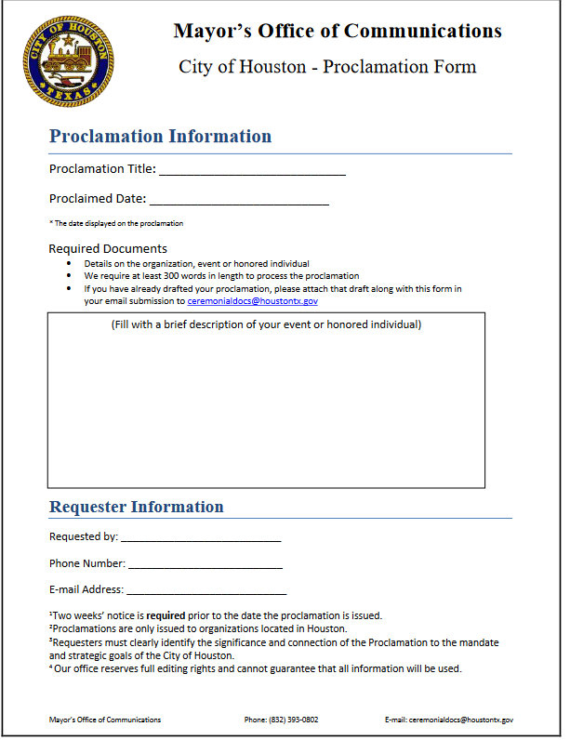

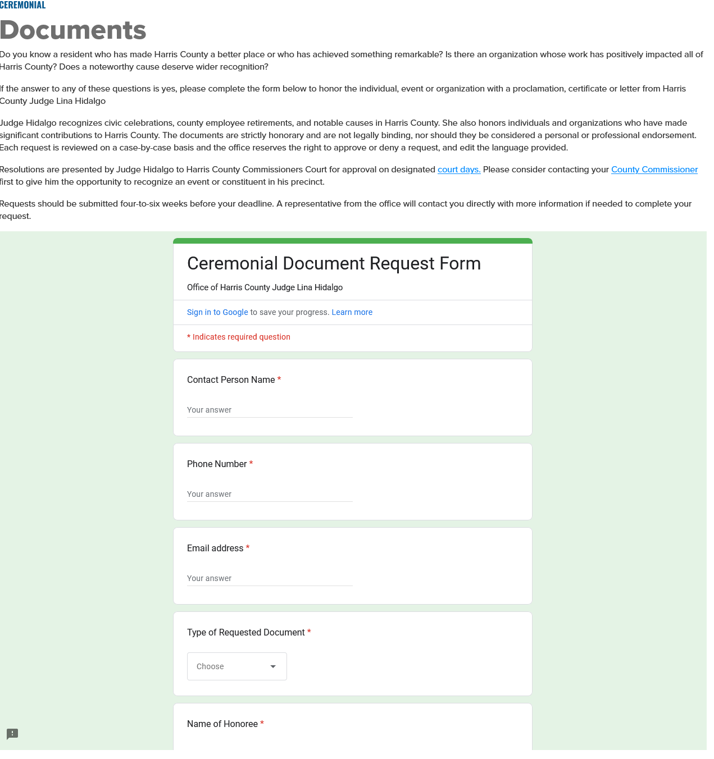

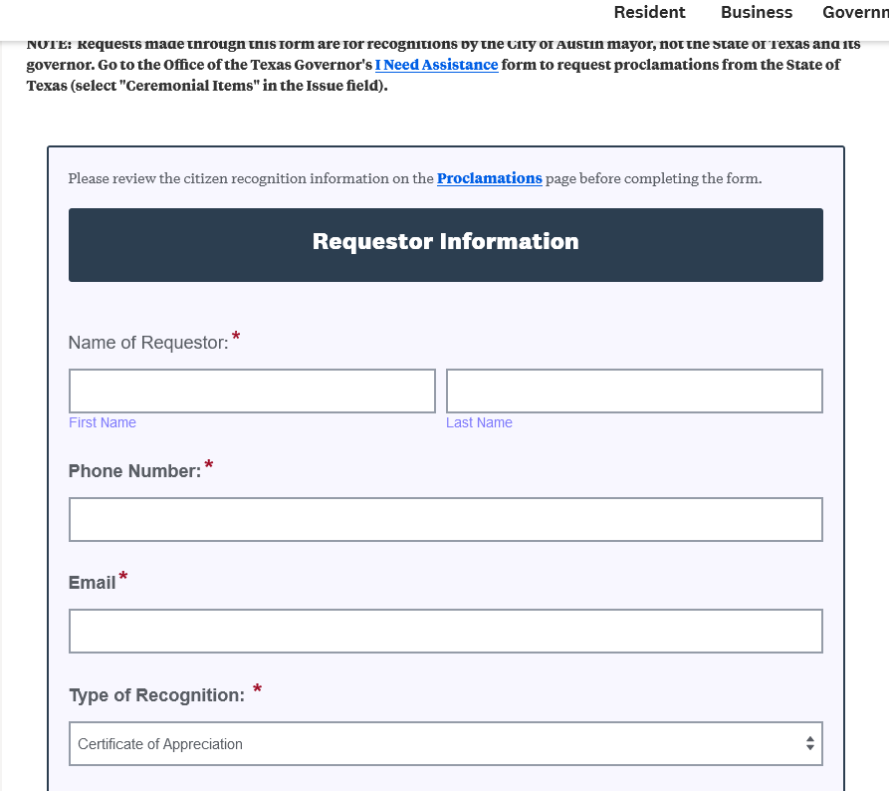
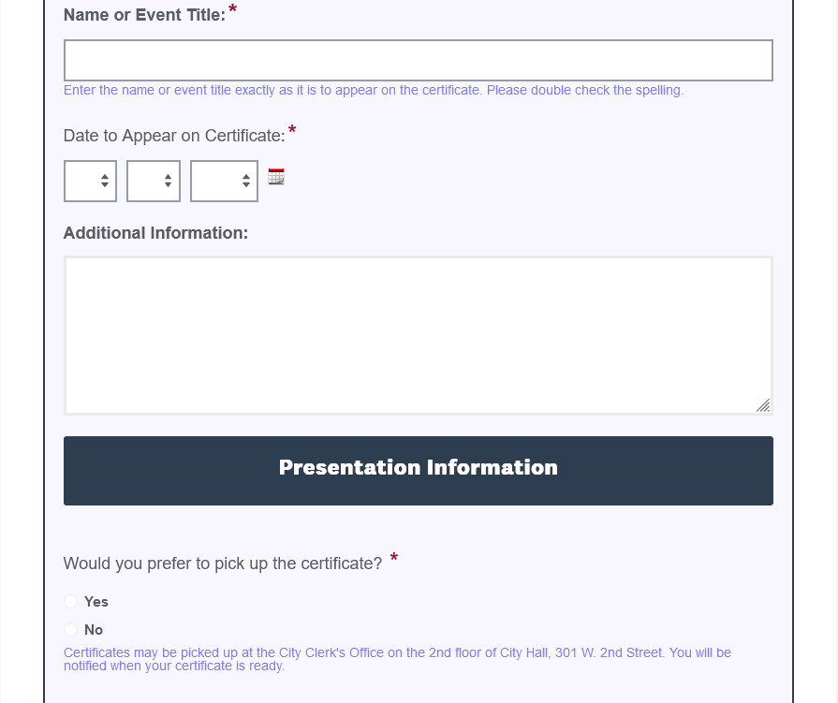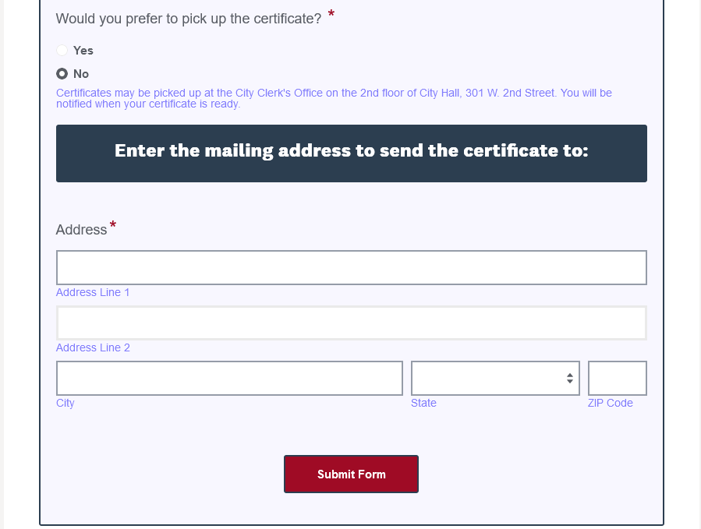

First Continental Congress Significant Facts
In response to the Boston Tea Party, the British Parliament passed a series of laws collectively known as the Intolerable Acts, with the intent to suppress unrest in colonial Boston by closing the port and establishing martial law. Across North America, colonists rose in solidarity with the people of Boston. Goods arrived in Massachusetts from as far south as Georgia, and by late spring 1774, nine of the colonies had agreed to a Continental Congress empowered to set the terms for a boycott of British goods. Virginia’s Committee of Correspondence is credited with originating the invitation and the colony of Connecticut was the first to respond. The colonies elected delegates to the First Continental Congress in several ways. Some delegates were elected through their respective colonial legislatures, some through committees of correspondence, and others by extralegal meetings. The Congress first convened in Carpenters’ Hall in Philadelphia on Sept. 5, 1774, with delegates from each of the 13 colonies except Georgia. (Georgia was facing a war with Native American tribes and the colony did not want to jeopardize British assistance.) On October 14, 1774, the First Continental Congress adopted their Declaration & Resolves. This stated the group’s objections to the Coercive Acts, listed the rights of the colonists, and itemized objections to British rule beyond the Intolerable Acts. The list of rights insisted that Colonists were “entitled to life, liberty, and property” and “that foundation of English liberty, and of all free government, is a right in the people to participate in their legislative council.” The First Continental Congress ended on October 26, 1774, when the delegates adopted a Petition addressed to “The King's Most Excellent Majesty.” Many delegates were skeptical about changing the king’s attitude towards the colonies but believed that every effort should be made to de-escalate the conflict before taking more radical action. By the time the Continental Congress met again, Lexington and Concord had occurred, and we were at war.

National Society
of the
Sons of the American Revolution

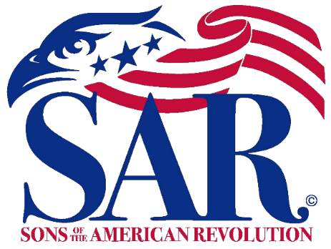

PROCLAMATION

THE FIRST CONTINENTAL CONGRESS

WHEREAS, The Sons of the American Revolution was founded in 1889 and is headquartered in Louisville, Kentucky and chartered by an Act of the United States Congress on June 9, 1906. With patriotic, historic and educational goals.

WHEREAS, The Sons of the American Revolution are celebrating the 250th anniversary of the founding of America, and have proclaimed 2024 to 2034 as the “Decade of the American Revolution.”

WHEREAS, In response to the Boston Tea Party, the British Parliament passed a series of laws collectively known as the Intolerable Acts, with the intent to suppress unrest in colonial Boston by closing the port and establishing martial law.

WHEREAS, Colonist across North America, rose in solidarity with the people of Boston, and by late spring 1774, nine of the colonies had agreed to a Continental Congress empowered to set the terms for a boycott of British goods. Some delegates were elected through their respective colonial legislatures, some through committees of correspondence, and others by extralegal meetings.

WHEREAS, The Congress first convened in Carpenters’ Hall in Philadelphia on Sept. 5, 1774, with delegates from each of the 13 colonies

WHEREAS, On October 14, 1774, the First Continental Congress adopted their Declaration and Resolves stating the group’s objections to the Coercive Acts, listed the rights of the colonists, and itemized objections to British rule beyond the Intolerable Acts.

WHEREAS, The list of rights insisted that Colonists were “entitled to life, liberty, and property” and “that foundation of English liberty, and of all free government, is a right in the people to participate in their legislative council”

WHEREAS, The First Continental Congress ended on October 26, 1774, when the
delegates adopted a Petition addressed to “The King’s Most Excellent Majesty, believing that every effort should be made to de-escalate the conflict before taking more radical action.

NOW, THEREFORE, (We,I), _(Name)________________, (City Council, Mayor, Position) of the (City, County, State)_________ encourage all Citizens to join with the Sons of the American Revolution and other patriotic, community, and Veterans organizations, on ___(Day)__, __(Date)__, _(Year)_ to commemorate this important event in the history of our great country.

IN WITNESS WHEREOF, I (We) hereunto set my hand and affixed the seal of the (City, County, State) this _(Day)_, __(Month)__, __(Year)__,

_____________________________________
(Seal) (Name)
(Title)

Battles of Lexington and Concord Significant Facts
In 1775 there were 7,000 British redcoats in America, with around 4,000 of these “Regulars” in Massachusetts. The royal governor, General Thomas Gage, was exercising broadly expanded powers. Tensions were high. Acting on intelligence that the militia were stockpiling weapons, Gage ordered British troops to march to Concord and seize the arms. The rebel intelligence network suggested the British were aiming for Lexington to capture Samuel Adams and John Hancock, two prominent Patriot leaders. However, the size of the British force was large enough to suggest they had bigger goals in mind. The British force marched to Lexington during the night; confronting local militia on Lexington Green - the village common - just as the sun was rising on April 19, 1775. Captain John Parker, a veteran of the French and Indian War, led a contingent of 80 Lexington militiamen, known as Minutemen, as they were required to deploy to fight at a minute’s notice. The Minutemen were mostly farmers or tradesmen, non-uniformed, and armed with a variety of firearms including muskets and fowling pieces. It is unclear who fired the first shot, but a skirmish ensued, during which eight militia were killed and one British soldier wounded. After restoring order, the British resumed the march to Concord. Militia from throughout the region, alerted the night before, raced to intercept the British and a battle was fought at Concord’s North Bridge. As the British departed for Boston a running battle ensued between the retreating British and the arriving militias. In all 95 Patriots and 273 British were killed. The Battles of Lexington and Concord roused New Englanders to join forces and lay siege to Boston, leading many formerly neutral colonists to support resistance. They showed that citizen soldiers could stand up to Regulars; something previously doubted by men on both sides. In 1837 Ralph Waldo Emerson penned the line, ‘Shot Heard Round the World’ in his poem, ‘Concord Hymn,’ written for the dedication of the battle monument at the North Bridge. That shot marked the point of no return on our march towards independence.

National Society
of the
Sons of the American Revolution

PROCLAMATION

THE BATTLES OF LEXINGTON AND CONCORD

WHEREAS, The Sons of the American Revolution are celebrating the 250th anniversary of the founding of America, and have proclaimed 2024 to 2034 as the “Decade of the American Revolution.”

WHEREAS, In 1775 there were 4,000 British redcoats in Massachusetts. General Thomas Gage, who was exercising broadly expanded powers. Acting on intelligence that the militia were stockpiling weapons, Gage ordered British troops to march to Concord and seize the arms.

WHEREAS, The British force marched to Lexington during the night; confronting local militia on Lexington Green - the village common - just as the sun was rising on April 19, 1775. The British force was met by a contingent of 80 Lexington militiamen, known as Minutemen, composed of farmers, tradesmen, non-uniformed men, and armed with a variety of firearms including muskets and fowling pieces.

WHEREAS, It is unclear who fired the first shot, but a skirmish ensued, during which eight militia were killed and one British soldier wounded. After restoring order, the British resumed the march to Concord.

WHEREAS, Militia from throughout the region, alerted the night before, raced to intercept the British and a battle was fought at Concord’s North Bridge. As the British departed for Boston a running battle ensued between the retreating British and the arriving militias. In all 95 Patriots and 273 British were killed.

WHEREAS The Battles of Lexington and Concord roused New Englanders to join forces and lay siege to Boston, leading many formerly neutral colonists to support resistance. They showed that citizen soldiers could stand up to Regulars; something previously doubted by men on both sides

NOW, THEREFORE, (We,I), _(Name)________________, (City Council, Mayor, Position) of the (City, County, State)_________ encourage all Citizens to join with the Sons of the American Revolution and other patriotic, community, and Veterans organizations, on ___(Day)__, __(Date)__, _(Year)_ to commemorate this important event in the history of our great country.
IN WITNESS WHEREOF, I (We) hereunto set my hand and affixed the seal of the (City, County, State) this _(Day)_, __(Month)__, __(Year)__,

_____________________________________
(Seal) (Name)
(Title)

