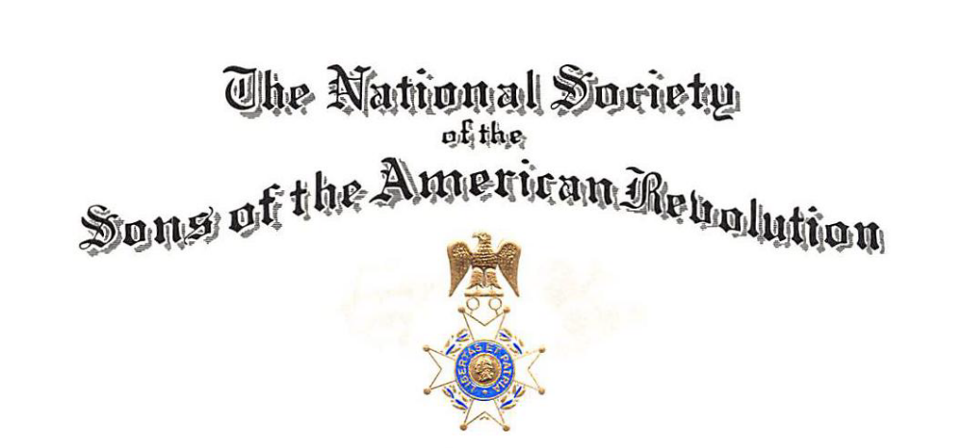

HONORING VETERANS ON VETERANS DAY 2026
PROCLAMATION
WHEREAS, Veterans Day is a time for the American people to recognize and honor the men and women who have served in the Armed Forces of the United States, defending the freedoms and principles upon which our nation was founded; and
WHEREAS, from the American Revolution to the present day, generations of Americans have answered the call to serve, demonstrating courage, sacrifice, and unwavering devotion to our country; and
WHEREAS, their service and sacrifices have helped preserve our nation's liberty and secure the blessings of freedom for future generations; and
WHEREAS, the Sons of the American Revolution, founded on the principles of patriotism, education, and historical preservation, proudly recognizes the contributions of America's veterans and remains committed to honoring those who have served;
NOW, THEREFORE, BE IT PROCLAIMED, that I, [Name and Title of Official], on behalf of [City/County/Governing Body], do hereby recognize November 11, 2026, as Veterans Day and encourage all citizens to honor our nation's veterans, express gratitude for their service, and reflect upon the sacrifices made to preserve our freedoms.
IN WITNESS WHEREOF, I have hereunto set my hand and caused the official seal of [City/County] to be affixed this________ day of _______________, 2026.

__________________________________
[Name of Official]
[Title]
__________________________________
[City/County/State]

